Software Design
for

Campus Management Application
at
World Skill Center (WSC)

Design Feature - Human Resource Management



Sustainable Outreach And Universal Leadership (SOUL) Limited
Version no 0.1
VERSION HISTORY
Date | Version No. | Created By | Updated Section | Updated By
23-03-2023 | Version 0.1 | Shruti Kumari

Content
1. Introduction 4
2. Literature review 4
3. Platform Overview 5
3.1 Platform requirements 5
4. Architecture 5
5. Organization Structure: 5
6. Design Overview: 6
6.1 Department 7
6.2 Designation 9
6.3 Branch 11
6.4 Employment Type 13
6.5 Employee Grade 15
6.6 Shift Type 17
6.7 Holiday List 21
6.8 Employee 23
6.9 Employee Group 30
6.10 Employee Health Insurance 32
6.11 Staffing Plan 34
6.12 Job Opening 37
6.13 Job Applicant 39
6.14 Employee Referral 43
6.15 Interview Type 46
6.16 Interview Round 48
6.17 Interview 50
6.18 Job Offer 53
6.19 Appointment Letter Template 57
6.20 Appointment Letter 59
6.21 Employee On-boarding Template 62
6.22 Employee On-boarding 65
6.23 Employee Skill Map 68
6.24 Employee Promotion 71
6.25 Employee Transfer 73
6.26 Grievance Type 77
6.27 Employee Grievance 79
6.28 Employee Separation Template 82
6.29 Employee Separation 84
6.30 Leave Type 88
6.31 Leave Period 92
6.32 Leave Policy 95
6.33 Leave Policy Assignment 97
6.34 Leave Allocation 100
6.35 Leave Application 103
6.36 Leave Block List 107
6.37 Compensatory Leave Request 110
6.38 Leave Encashment 114
6.39 Shift Assignment 118
6.40 Shift Request 120
6.41 Attendance 123
6.42 Employee Attendance Tool 127
6.43 Attendance Request 130
6.44 Employee Checkin 132
6.45 Appraisal Template 135
6.46 Appraisal 138

- Introduction

Campus management project for WSC aims at providing an efficient, secure, and user-friendly platform to manage and automate the various processes. It is an integrated system that provides all the necessary tools to manage the various aspects of running a University. This web-based solution enables administrators and faculty to easily track and manage activities related to student registration and enrollment, faculty and staff management, financial management, facility management, and more. Additionally, it also provides features such as reporting and analytic, notification to students and parents using emails.
Scope of project:
- Students Management Modules
- Academic System
- Procurement & Inventory Management
- Human Resources Management System
- Finance and Accounting System
- Training and Placement
- Infrastructure

- Literature review
The following section first explains the evolution of ERP system and some of its characteristics. It also explores the various modules available in an ERP software. Knowledge-intensive nature of ERP systems and ERP system adoption is also analyzed. Finally it looks into critical success factors for ERP system implementation as well as benefits of ERP implementation.

- Platform Overview

3.1 Platform requirements

3.1.1 Software Stack
Our application use Frappe framework as the major software stack which is an open-source full stack web framework written in Python and JavaScript that is used to develop and maintain web applications. It is designed to be simple, easy to use, and fast. It is built on top of the popular Django web framework. Frappe provides a powerful set of tools for building web applications with a focus on scalability and extensibility. It provides a powerful ORM, a powerful templating system, and a comprehensive set of APIs for building web applications. Frappe is also designed for ease of use, with a focus on reducing development time and building an intuitive admin interface. It also features a seamless integration with other open-source projects such as Redis, MongoDB, and MySQL, as well as a host of APIs and other tools.

3.2.2 Hosting requirement
Our application requires a Linux-based hosting environment. It requires at least 1GB of RAM, 2GB of disk space, and preferably an Ubuntu 16.04 or higher operating system. It also requires a web server such as Apache or Nginx, MariaDB 10.1 or higher, and Python 2.7.x or higher. Additionally, it requires an SMTP server to send emails and an SSL certificate to enable HTTPS.

- Architecture
Our application is based on a web-based, modular, service-oriented architecture (SOA), which allows for the development of custom applications and services that can be integrated with the core Our application platform. It is built on a combination of JavaScript, Python, and MySQL. The architecture of Our application consists of multiple layers, each with its own set of functions and services. At the highest level are the user interface, user experience, and application logic components. These components provide the user with an interface to the Our application system and the ability to interact with the underlying data and services. Below the user interface layer is the data layer, which is responsible for managing the storage and retrieval of data and services. This layer is powered by a combination of MySQL and PostgreSQL databases. The data layer is also responsible for providing secure access to the data and services. The application layer is responsible for providing access to the data and services, as well as providing the business logic that drives the system. The application layer is powered by a combination of Python and JavaScript, and is responsible for providing the core capabilities of the system, such as authentication, authorization, reporting, and analytics. Finally, the service layer is the layer that connects the application layer to the user interface layer. It provides the ability to integrate the Our application system with external systems and services, such as third-party APIs and web services. The service layer is powered by a combination of web services and web sockets. Following is a diagram showing a representation of the architecture of our application:

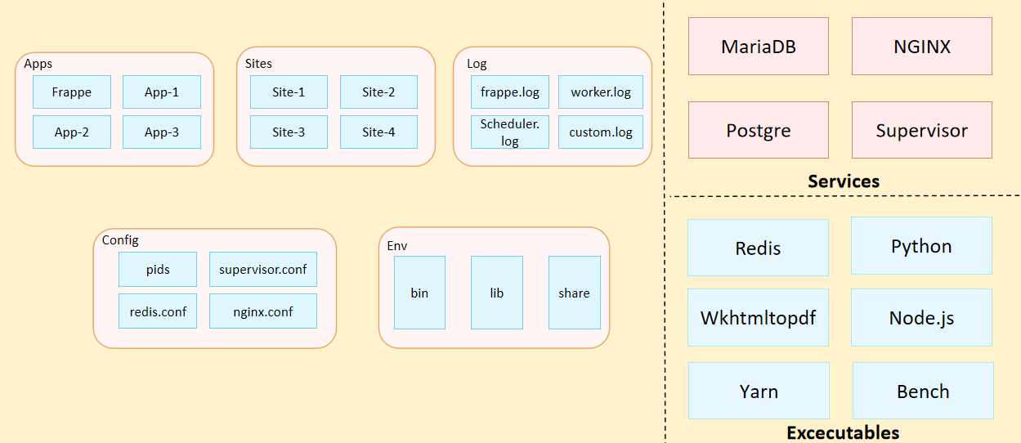
Fig: Architecture of Our Application

- Organization Structure:
Input required form WSC

- Design Overview:

6.1 Department
    - Overview
A Department is a specialized functional area or a division within an organization.

    - Description of Problem
Create a page containing all Information about department in the system including set Leave Block List, and also Leave and Expense Approvers for the same.

    - Dependency
Before creating a Department, it is advisable you create the following documents:
- Company

    - A Table of Contents
- Main Table:- TabDepartment
- Child Table:- TabDepartment Approver

    - Flow Chart
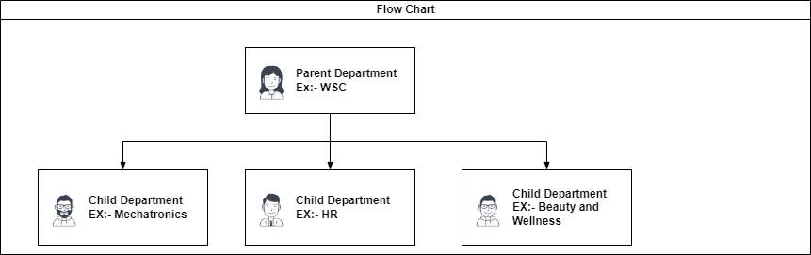

    - Use Case

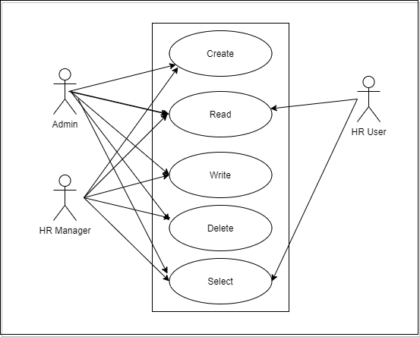

    - Form Elaboration
SL No | Label | Type | Mandatory
1 | Department | Data | 1
2 | Department Alias | Data | 1
3 | Parent Department | Link | 0
5 | Company | Link | 1
6 | Is Group | Check | 0
7 | Is Stream | Check | 0
8 | Disabled | Check | 0
10 | Payroll Cost Center | Link | 0
12 | Leave Block List | Link | 0
14 | Shift Request Approver | Table | 0
15 | Leave Approver | Table | 0
16 | Expense Approver | Table | 0
17 | lft | Int | 0
18 | rgt | Int | 0
19 | Old Parent | Data | 0

    - Screen Authorization
Sl No. | Role | Level | Select | Read | Write | Create | Delete | Submit
1 | Admin | 0 | 1 | 1 | 1 | 1 | 1 | 0
2 | HR Manager | 0 | 1 | 1 | 1 | 1 | 1 | 0
3 | HR User | 0 | 1 | 1 | 0 | 0 | 0 | 0

    - Component And Module
Module Related:- Module Related:- Education, Finance, HR,Material Management

    - Business Logic
- Go to the Department list, click on New.
- Enter Department name.
- Select Company name.
- Select Leave Block List (optional) applicable for this department.
- Save

    - Path of the screen
Home > Human Resources > Employee > Department

6.2 Designation

6.2.1 Overview
A Designation is the official job titles given to employees..

6.2.2 Description of Problem
Create a page containing all Information about designation in the system including the skills required for that designation.

6.2.3 Dependency
Before creating a Designation, it is advisable you create the following documents:
- Skill

6.2.4 A Table of Contents
- Main Table:- TabDesignation
- Child Table:- TabSkills

6.2.5 Use Case

6.2.6 Form Elaboration
SL No | Label | Type | Mandatory
1 | Designation | Data | 1
2 | Description | Text | 0

6.2.7 Screen Authorization
Sl No. | Role | Level | Select | Read | Write | Create | Delete | Submit
1 | Admin | 0 | 1 | 1 | 1 | 1 | 1 | 0
2 | HR Manager | 0 | 1 | 1 | 1 | 1 | 1 | 0
3 | HR User | 0 | 1 | 1 | 0 | 0 | 0 | 0

6.2.8 Component And Module
Module Related:- Module Related:- Education, Finance, HR,Material Management

6.2.9 Business Logic
- Go to Designation List, and click on New.
- Enter Designation Name and add Description
- Enter the required skills in Required Skills Table.
- Save

6.2.10 Path of the screen
Home > Human Resources > Employee > Designation

6.3 Branch

6.3.1 Overview
Branch is the different section of the organization.

6.3.2 Description of Problem
Create a form to collect information of Branch

6.3.3 Dependency
No Dependency

6.3.4 A Table of Contents
- Main Table:- TabBranch

6.3.5 Flow Chart
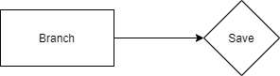

6.3.6 Use case

6.2.7 Form Elaboration
SL No | Label | Type | Mandatory
1 | Branch | Data | 1

6.3.8 Screen Authorization
Sl No. | Role | Level | Select | Read | Write | Create | Delete | Submit
1 | Admin | 0 | 1 | 1 | 1 | 1 | 1 | 0
2 | HR Manager | 0 | 1 | 1 | 1 | 1 | 1 | 0
3 | HR User | 0 | 1 | 1 | 0 | 0 | 0 | 0

6.3.9 Component And Module
Module Related:- Module Related:- Education, Finance, HR,Material Management

6.3.10 Business Logic

1)Go to Branch List, and click on New.

2)Enter Branch name and add.

3)Save

6.3.11 Path of the screen
Home > Human Resources > Employee > Branch

6.4 Employment Type

6.4.1 Overview
Employment Type is the different categories of employee having their own wage and leave entitlements.

6.4.2 Description of Problem
Create a form to collect information of Employment Type like Intern,Full-time and so on.

6.4.3 Dependency
No Dependency

6.4.4 A Table of Contents
- Main Table:- TabEmployment Type

6.4.5 Flow Chart
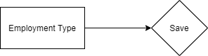

6.4.6 Use case

6.4.7 Form Elaboration
SL No | Label | Type | Mandatory
1 | Employment Type | Data | 1

6.4.8 Screen Authorization
Sl No. | Role | Level | Select | Read | Write | Create | Delete | Submit
1 | Admin | 0 | 1 | 1 | 1 | 1 | 1 | 0
2 | HR Manager | 0 | 1 | 1 | 1 | 1 | 1 | 0
3 | HR User | 0 | 1 | 1 | 0 | 0 | 0 | 0

6.4.9 Component And Module
Module Related:- HR

6.4.10 Business Logic

1)Go to Employment Type, and click on New.

2)Enter Employment type name and add.

3)Save

6.4.11 Path of the screen
Home > Human Resources > Employee > Employment Type

6.5 Employee Grade

6.5.1 Overview
Employee Grade is a grouping of the employees with similar positions or values in order to assign compensation rates and salary structures.

6.5.2 Description of Problem
Create a form to collect information of Employee grade with the information like name and default salary structure.

6.5.3 Dependency
No Dependency

6.5.4 A Table of Contents
- Main Table:- TabEmployee Grade

6.5.5 Flow Chart
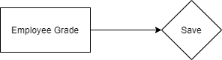

6.5.6 Use case

6.5.7 Form Elaboration
SL No | Label | Type | Mandatory | Option
1 | Employee Grade | Data | 1
2 | Default Salary Structure | Link | 0 | Salary Structure

6.5.8 Screen Authorization
Sl No. | Role | Level | Select | Read | Write | Create | Delete | Submit
1 | Admin | 0 | 1 | 1 | 1 | 1 | 1 | 0
2 | HR Manager | 0 | 1 | 1 | 1 | 1 | 1 | 0
3 | HR User | 0 | 1 | 1 | 0 | 0 | 0 | 0

6.5.9 Component And Module
Module Related:- HR

6.5.10 Business Logic

1)Go to Employee Grade, and click on New.

2)Enter Employee grade name and Default Salary Structure.

3)Save

6.5.11 Path of the screen
Home > Human Resources > Employee > Employee Grade

6.6 Shift Type

6.6.1 Overview

The Shift Type document allows you to define the different types of Shifts in your Organization and set up auto attendance for the shift.

6.6.2 Description of Problem
Create a form to collect information of different shift type with following conditions:
- Enable Auto Attendance Checkbox.
- Without enabling Auto Attendance.
Auto Attendance Settings:
Determine Check-in and Check-out: This setting determines how your check-in logs should be interpreted by the auto attendance system.
  - Alternating entries as IN and OUT during the same shift: The first entry is taken as IN followed by the next entry as OUT and the following entry as IN and so on. Employee Check-in may not always have an IN/OUT log type. Not all biometric devices return Log Type for every log. For such scenarios you can use this option.
  - Strictly based on Log Type in Employee Check-in: The check-in is determined as IN or OUT strictly based on the 'Log Type' in the Employee Check-in record. This should be used when the logs that are being recorded in system have the exact log type.

Working Hours Calculation Based On: Working hours can be calculated either by including the breaks in between the shift or by excluding the breaks. This can be configured using the following options:

  - First Check-in and Last Check-out:
    - Use this option when you want to include breaks or all out/in entries in your working hours.
    - Selecting this option calculates the working hours by considering the first IN and last OUT Employee Check-in during the shift. The time difference between the two is considered as the actual working hours.
    - In case the IN/OUT is determined by alternating entries then the first Employee Check-in is considered as IN and the last Employee Check-in is considered as OUT for the purpose of calculating working hours.
  - Every Valid Check-in and Check-out:
    - Selecting this option excludes the time during which the Employee is checked out.
    - i.e. Only the time during which the employee is checked in is calculated as working hours.

Begin check-in before shift start time (in minutes): Often employees would check-in a few minutes before the shift start time. To consider these check-ins as part of the shift during the calculation of working hours and marking attendance, you can set up this value accordingly.
Allow check-out after shift end time (in minutes): Often employees would check-out after the shift end time. To consider these check-outs as part of the shift during the calculation of attendance, you can set up this value accordingly.
Working Hours Threshold for Half Day: If the actual number of working hours is less than the given value in this field then the employee attendance is marked as 'Half Day'. If you never want to mark Half Day based on working hours, you should set this value to zero.
Working Hours Threshold for Absent: If the actual number of working hours is less than the given value in this field then the employee attendance is marked as 'Absent'. If you never want to mark Absent based on working hours, you should set this value to zero.
Process Attendance After: The date from which 'Auto Attendance' should start marking attendance. You should set it to a date after which you have Employee Check-in records for this shift.
Last Sync of Check-in: This is the timestamp up to which Employee Check-in records have been synced.

6.6.3 Dependency
No Dependency

6.6.4 A Table of Contents
- Main Table:- TabShift Type

6.6.5 Flow Chart
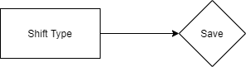

6.6.6 Use case
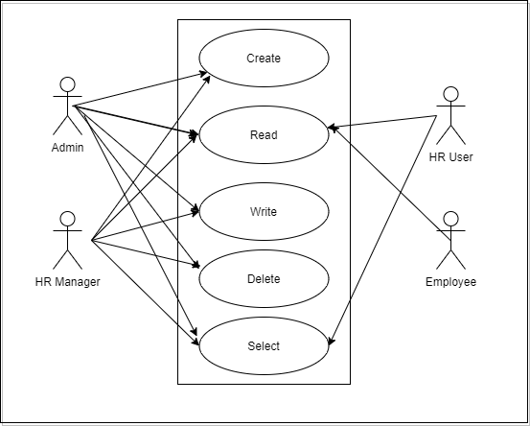

6.6.7 Form Elaboration
SL No. | Label | Type | Mandatory | Options
1 | Start Time | Time | 1
2 | End Time | Time | 1
3 |  | Column Break | 0
4 | Holiday List | Link | 0 | Holiday List
5 | Enable Auto Attendance | Check | 0
6 | Auto Attendance Settings | Section Break | 0
7 | Determine Check-in and Check-out | Select | 0 | Alternating entries as IN and OUT during the same shift  Strictly based on Log Type in Employee Checkin
8 | Working Hours Calculation Based On | Select | 0 | First Check-in and Last Check-out  Every Valid Check-in and Check-out
9 | Begin check-in before shift start time (in minutes) | Int | 0
10 | Allow check-out after shift end time (in minutes) | Int | 0
11 |  | Column Break | 0
12 | Working Hours Threshold for Half Day | Float | 0
13 | Working Hours Threshold for Absent | Float | 0
14 | Process Attendance After | Date | 0
15 | Last Sync of Checkin | Datetime | 0
16 | Grace Period Settings For Auto Attendance | Section Break | 0
17 | Enable Entry Grace Period | Check | 0
18 | Late Entry Grace Period | Int | 0
19 |  | Column Break | 0
20 | Enable Exit Grace Period | Check | 0
21 | Early Exit Grace Period | Int | 0

6.6.8 Screen Authorization
Sl No. | Role | Level | Select | Read | Write | Create | Delete | Submit
1 | Admin | 0 | 1 | 1 | 1 | 1 | 1 | 0
2 | HR Manager | 0 | 1 | 1 | 1 | 1 | 1 | 0
3 | HR User | 0 | 1 | 1 | 0 | 0 | 0 | 0
4 | Employee | 0 | 0 | 1 | 0 | 0 | 0 | 0

6.6.9 Component And Module
Module Related:- HR

6.6.10 Business Logic

1)Go to Shift Type, and click on New.

2)Enter the Shift Name,Start Time and End Time.

3)Save

6.6.11 Path of the screen
Home > Human Resources > Shift Management > Shift Type

6.7 Holiday List

6.7.1 Overview

The Holiday List will have all the standard Holiday List of their employees.

6.7.2 Description of Problem
Create a form to collect information of Holiday List and mention Weekly Holidays and so on.

6.7.3 Dependency
No Dependency

6.7.4 A Table of Contents
1)Main Table:- TabHoliday List

6.7.5 Flow Chart
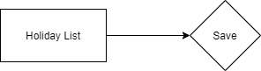

6.7.6 Use case
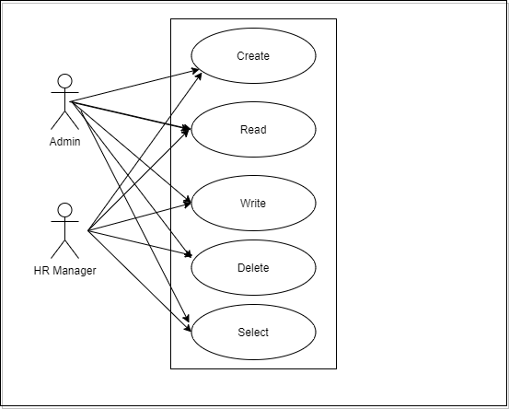

6.7.7 Form Elaboration
SL No. | Label (Fields) | Type (Fields) | Options (Fields)
1 | Holiday List Name | Data
2 | From Date | Date
3 | To Date | Date
4 |  | Column Break
5 | Total Holidays | Int
6 | Add Weekly Holidays | Section Break
7 | Weekly Off | Select | Sunday  Monday  Tuesday  Wednesday  Thursday  Friday  Saturday
8 | Add to Holidays | Button
9 | Holidays | Section Break
10 | Holidays | Table | Holiday
11 | Clear Table | Button

6.7.8 Screen Authorization
Sl No. | Role | Level | Select | Read | Write | Create | Delete | Submit
1 | Admin | 0 | 1 | 1 | 1 | 1 | 1 | 0
2 | HR Manager | 0 | 1 | 1 | 1 | 1 | 1 | 0

6.7.9 Component And Module
Module Related:- HR,Education,Finance,Material Management

6.7.10 Business Logic

1)Go to Holiday List, and click on New.

2)Enter the Holiday List Name.It can be based on the Fiscal Year or Location or Department as per the requirement.

3)Select From Date and To Date for the Holiday List.

4)Save

6.7.11 Path of the screen
Home > Human Resources > Leaves > Holiday List

6.8 Employee

6.8.1 Overview

An Employee is an individual who works part-time or full-time under a contract of employment, and has recognized rights and duties of your company is your Employee.

6.8.2 Description of Problem
Create a form to collect information of Employee like Employee personal details like first name,middle name,last name,DOB,DOJ,Company Details,Joining details,Personal details,Attendance & Leaves and so on.

6.8.3 Dependency
Before creating a Designation, it is advisable you create the following documents:
- Employee Type
- Department
- Employee Grade
- Branch
- Designation
- Holiday List
- Shift Type

6.8.4 A Table of Contents
1) Main Table:- TabEmployee

6.8.5 Flow Chart

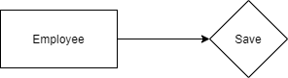

6.8.6 Use case

6.8.7 Form Elaboration
SL No. | Label | Type | Mandatory | Options
1 | Overview | Tab Break | 0
2 |  | Section Break | 0
3 | Employee | Data | 0
4 | Series | Select | 0 | HR-EMP-
5 | First Name | Data | 1
6 | Middle Name | Data | 0
7 | Last Name | Data | 0
8 | Full Name | Data | 0
9 |  | Column Break | 0
10 | Gender | Link | 1 | Gender
11 | Date of Birth | Date | 1
12 | Salutation | Link | 0 | Salutation
13 |  | Column Break | 0
14 | Date of Joining | Date | 1
15 | Image | Attach Image | 0
16 | Status | Select | 1 | Active  Inactive  Suspended  Left
17 | User Details | Section Break | 0
18 | User ID | Link | 0 | User
19 | Create User | Button | 0
20 | Create User Permission | Check | 0
21 | Company Details | Section Break | 0
22 | Company | Link | 1 | Company
23 | Department | Link | 0 | Department
24 | Employee Number | Data | 0
25 |  | Column Break | 0
26 | Designation | Link | 0 | Designation
27 | Reports to | Link | 0 | Employee
28 |  | Column Break | 0
29 | Branch | Link | 0 | Branch
30 | Joining | Tab Break | 0
31 | Offer Date | Date | 0
32 |  | Column Break | 0
33 | Confirmation Date | Date | 0
34 | Contract End Date | Date | 0
35 |  | Column Break | 0
36 | Notice (days) | Int | 0
37 | Date Of Retirement | Date | 0
38 | Address & Contacts | Tab Break | 0
39 | Mobile | Data | 0 | Phone
40 |  | Column Break | 0
41 | Personal Email | Data | 0 | Email
42 | Company Email | Data | 0 | Email
43 |  | Column Break | 0
44 | Preferred Contact Email | Select | 0 | Company Email  Personal Email  User ID
45 | Prefered Email | Data | 0 | Email
46 | Unsubscribed | Check | 0
47 | Address | Section Break | 0
48 | Current Address | Small Text | 0
49 | Current Address Is | Select | 0 | Rented  Owned
50 |  | Column Break | 0
51 | Permanent Address | Small Text | 0
52 | Permanent Address Is | Select | 0 | Rented  Owned
53 | Emergency Contact | Section Break | 0
54 | Emergency Contact Name | Data | 0
55 |  | Column Break | 0
56 | Emergency Phone | Data | 0 | Phone
57 |  | Column Break | 0
58 | Relation | Data | 0
59 | Attendance & Leaves | Tab Break | 0
60 | Attendance Device ID (Biometric/RF tag ID) | Data | 0
61 |  | Column Break | 0
62 | Holiday List | Link | 0 | Holiday List
63 | Salary | Tab Break | 0
64 | Cost to Company (CTC) | Currency | 0 | salary_currency
65 | Salary Currency | Link | 0 | Currency
66 | Salary Mode | Select | 0 | Bank  Cash  Cheque
67 | Bank Details | Section Break | 0
68 | Bank Name | Data | 0
69 | Bank A/C No. | Data | 0
70 | Personal | Tab Break | 0
71 | Marital Status | Select | 0 | Single  Married  Divorced  Widowed
72 | Family Background | Small Text | 0
73 |  | Column Break | 0
74 | Blood Group | Select | 0 | A+  A-  B+  B-  AB+  AB-  O+  O-
75 | Health Details | Small Text | 0
76 | Passport Details | Section Break | 0
77 | Passport Number | Data | 0
78 | Valid Upto | Date | 0
79 |  | Column Break | 0
80 | Date of Issue | Date | 0
81 | Place of Issue | Data | 0
82 | Profile | Tab Break | 0
83 | Bio / Cover Letter | Text Editor | 0
84 | Educational Qualification | Section Break | 0
85 | Education | Table | 0 | Employee Education
86 | Previous Work Experience | Section Break | 0 | Simple
87 | External Work History | Table | 0 | Employee External Work History
88 | History In Company | Section Break | 0 | Simple
89 | Internal Work History | Table | 0 | Employee Internal Work History
90 | Exit | Tab Break | 0
91 | Resignation Letter Date | Date | 0
92 | Relieving Date | Date | 0
93 |  | Column Break | 0
94 | Exit Interview Held On | Date | 0
95 | New Workplace | Data | 0
96 |  | Column Break | 0
97 | Leave Encashed? | Select | 0 | Yes  No
98 | Encashment Date | Date | 0
99 | Feedback | Section Break | 0
100 | Reason for Leaving | Small Text | 0
101 |  | Column Break | 0
102 | Feedback | Small Text | 0

6.8.8 Screen Authorization
Sl No. | Role | Level | Select | Read | Write | Create | Delete | Submit
1 | Admin | 0 | 1 | 1 | 1 | 1 | 1 | 0
2 | HR Manager | 0 | 1 | 1 | 1 | 1 | 1 | 0
3 | HR User | 0 | 1 | 1 | 1 | 1 | 1 | 0
4 | Employee | 0 | 0 | 1 | 0 | 0 | 0 | 0

6.8.9 Component And Module
Module Related:- HR,Education,Finance,Material Management

6.8.10 Business Logic

1)Go to Employee, and click on New.

2)Enter the details of the Employee

5)Save

6.8.11 Path of the screen
Home > Human Resources > Employee

6.9 Employee Group

6.9.1 Overview

An Employee Group is grouping of Employees based on some attributes such as Designation, Grade, Branch, etc.

6.9.2 Description of Problem
Create a form to group the Employees at a place on the basis of Designation,Grade,Branch and so on.

6.9.3 Dependency
Before creating a Designation, it is advisable you create the following documents:
- Employee

6.9.4 A Table of Contents
1)Main Table:- TabEmployee Group
2)Child Table:-TabEmployee Group Table

6.9.5 Flow Chart

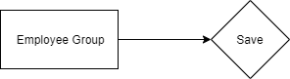

6.9.6 Use case

6.9.7 Form Elaboration
SL No. | Label | Type | Mandatory | Options
1 | Name | Data | 1
2 | Employee | Section Break | 0
3 | Employee | Table | 0 | Employee Group Table

6.9.8 Screen Authorization
Sl No. | Role | Level | Select | Read | Write | Create | Delete | Submit
1 | Admin | 0 | 1 | 1 | 1 | 1 | 1 | 0
2 | HR Manager | 0 | 1 | 1 | 1 | 1 | 1 | 0

6.9.9 Component And Module
Module Related:- HR,Education,Finance,Material Management

6.9.10 Business Logic

1) Go to Employee Group, and click on New.

2) Enter the name

3) Select and add Employee ID to the group.The Employee Name will get automatically fetched.

4) Save

6.9.11 Path of the screen
Home > Human Resources > Employee > Employee Group

6.10 Employee Health Insurance

6.10.1 Overview

An Employee Health Insurance is a benefit extended by the company to their employees. When a company provides health insurance assistance, they pay full or part premiums for the health insurance policy.

6.10.2 Description of Problem
Create a form to collect details of Employee Health Insurance and link it to that particular Employee’s master.

6.10.3 Dependency
No Dependency.

6.10.4 A Table of Contents
1)Main Table:- TabEmployee Health Insurance.

6.10.5 Flow Chart

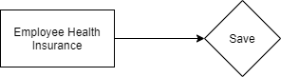

6.10.6 Use case
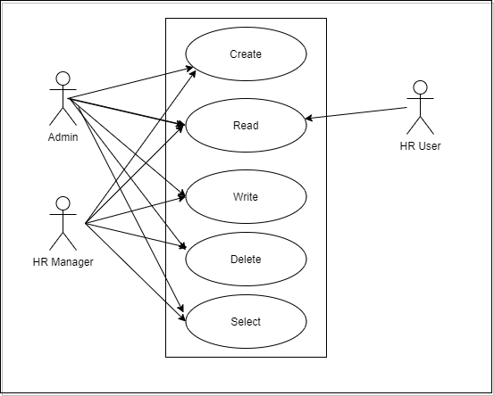

6.10.7 Form Elaboration

SL No | Label | Type | Mandatory
1 | Employee Health Insurance | Data | 1

6.10.8 Screen Authorization
Sl No. | Role | Level | Select | Read | Write | Create | Delete | Submit
1 | Admin | 0 | 1 | 1 | 1 | 1 | 1 | 0
2 | HR Manager | 0 | 1 | 1 | 1 | 1 | 1 | 0
3 | HR User | 0 | 0 | 1 | 0 | 0 | 0 | 0

6.10.9 Component And Module
Module Related:- HR

6.10.10 Business Logic

1) Go to Employee Health Insurance list, and click on New.

2) Enter the Health Insurance Name.

3) Save

6.10.11 Path of the screen
Home > Human Resources > Employee > Employee Health Insurance

6.11 Staffing Plan

6.11.1 Overview

A Staffing Plan helps you to plan manpower requirements for your Company.

6.11.2 Description of Problem
Create a form to efficiently plan and budget new hiring for a period. It will store information like Name,Staffing Details and so on.

6.11.3 Dependency
Before creating a Staffing Plan, it is advisable you create the following documents:
- Department
- Designation

6.11.4 A Table of Contents
1) Main Table:- TabStaffing Plan
2) Child Table:-TaStaffing Plan Detail

6.11.5 Flow Chart

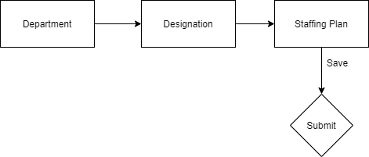

6.11.6 Use case

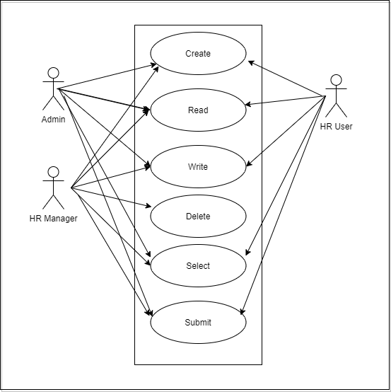

6.11.7 Form Elaboration
SL No. | Label | Type | Mandatory | Options
1 | Company | Link | 1 | Company
2 | Department | Link | 0 | Department
3 |  | Column Break | 0
4 | From Date | Date | 1
5 | To Date | Date | 1
6 | Details | Section Break | 0
7 | Get Job Requisitions | Button | 0
8 | Staffing Details | Table | 1 | Staffing Plan Detail
9 |  | Section Break | 0
10 | Total Estimated Budget | Currency | 0
11 | Amended From | Link | 0 | Staffing Plan

6.11.8 Screen Authorization
Sl No. | Role | Level | Select | Read | Write | Create | Delete | Submit
1 | Admin | 0 | 1 | 1 | 1 | 1 | 1 | 1
2 | HR Manager | 0 | 1 | 1 | 1 | 1 | 1 | 1
3 | HR User | 0 | 1 | 1 | 1 | 1 | 0 | 1

6.11.9 Component And Module
Module Related:- HR

6.11.10 Business Logic

1) Go to Staffing Plan list,click on New.

2) Enter the Name,From and To Date and select the Department for which you want to create the Staffing Plan.

3) Enter the Staffing Plan Details such as Designation,Vacancies,Estimated Cost Per Position,Total Estimated Cost and Number of Positions.

4) Save and Submit

6.11.11 Path of the screen
Home > Human Resources > Recruitment > Staffing Plan

6.12 Job Opening

6.12.1 Overview

A Job Opening is a job vacancy in your Company. You can make a record of the open vacancies in your company using Job Opening.

6.12.2 Description of Problem
Create a form to collect the Job Opening with the information like Job Title,Designation,Department and so on.

6.12.3 Dependency
Before creating a Designation, it is advisable you create the following documents:
- Staffing Plan
- Department
- Designation

6.12.4 A Table of Contents
1) Main Table:- TabJob Opening

6.12.5 Flow Chart
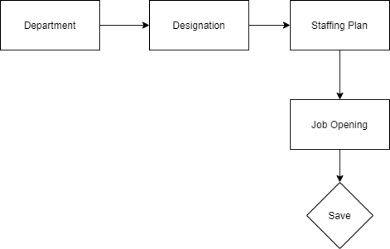

6.12.6 Use case
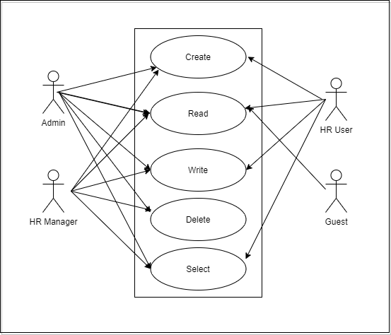

6.12.7 Form Elaboration
SL No. | Label | Type | Mandatory | Options
1 | Job Title | Data | 1
2 | Company | Link | 1 | Company
3 | Status | Select | 0 | Open  Closed
4 |  | Column Break | 0
5 | Designation | Link | 1 | Designation
6 | Department | Link | 0 | Department
7 | Staffing Plan | Link | 0 | Staffing Plan
8 | Planned number of Positions | Int | 0
9 |  | Section Break | 0
10 | Publish on website | Check | 0
11 | Route | Data | 0
12 |  | Column Break | 0
13 | Job Application Route | Data | 0
14 |  | Section Break | 0
15 | Description | Text Editor | 0
16 |  | Section Break | 0
17 | Currency | Link | 0 | Currency
18 | Lower Range | Currency | 0 | currency
19 | Upper Range | Currency | 0 | currency
20 |  | Column Break | 0
21 | Publish Salary Range | Check | 0

6.12.8 Screen Authorization
Sl No. | Role | Level | Select | Read | Write | Create | Delete | Submit
1 | Admin | 0 | 1 | 1 | 1 | 1 | 1 | 1
2 | HR Manager | 0 | 1 | 1 | 1 | 1 | 1 | 1
3 | HR User | 0 | 1 | 1 | 1 | 1 | 0 | 1
4 | Guest | 0 | 0 | 1 | 0 | 0 | 0 | 0

6.12.9 Component And Module
Module Related:- HR

6.12.10 Business Logic

1) Go to Job Opening list,click on New.

2) Enter the Job Title .

3) Select the Designation and Department.Based on Designation selected,appropriate Staffing Plan and Planned Number of Positions will be fetched.

4) Save

6.12.11 Path of the screen
Home > Human Resources > Recruitment > Job Opening

6.13 Job Applicant

6.13.1 Overview

A Job Applicant is a person who applies for a job in your Company against a particular Job Opening.

6.13.2 Description of Problem
Create a form to collect the details of a Job Applicant like Applicant Name,Email Address,Personal Details,Resume,Salary Details and so on.

6.13.3 Dependency
Before creating a Job Applicant, it is advisable you create the following documents:
1)Staffing Plan
2)Department
3)Job Opening

6.13.4 A Table of Contents
1) Main Table:- TabJob Applicant

6.13.5 Flow Chart

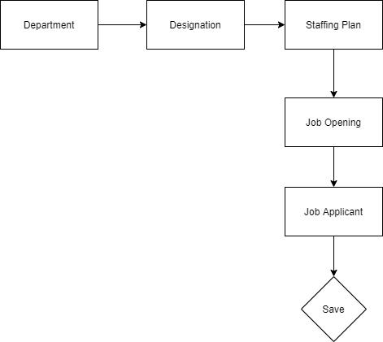

6.13.6 Use case
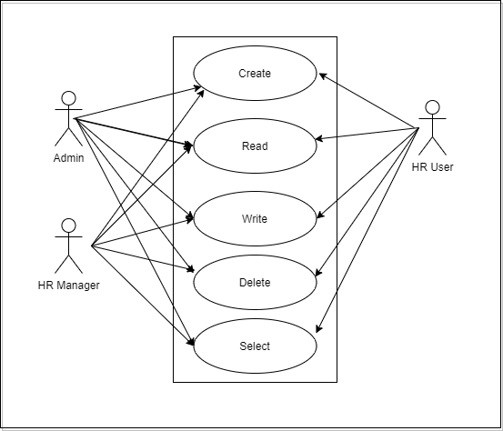

6.13.7 Form Elaboration
SL No. | Label | Type | Mandatory | Options
1 | Details | Section Break | 0
2 | Applicant Name | Data | 1
3 | Email Address | Data | 1 | Email
4 | Phone Number | Data | 0 | Phone
5 | Country | Link | 0 | Country
6 |  | Column Break | 0
7 | Job Opening | Link | 0 | Job Opening
8 | Designation | Link | 0 | Designation
9 | Status | Select | 1 | Open  Replied  Rejected  Hold  Accepted
10 | Source and Rating | Section Break | 0
11 | Source | Link | 0 | Job Applicant Source
12 | Source Name | Link | 0 | Employee
13 | Employee Referral | Link | 0 | Employee Referral
14 |  | Column Break | 0
15 | Applicant Rating | Rating | 0
16 | Resume | Section Break | 0
17 | Notes | Data | 0
18 | Cover Letter | Text | 0
19 | Resume Attachment | Attach | 0
20 | Resume Link | Data | 0
21 | Salary Expectation | Section Break | 0
22 | Currency | Link | 0 | Currency
23 |  | Column Break | 0
24 | Lower Range | Currency | 0 | currency
25 | Upper Range | Currency | 0 | currency

6.13.8 Screen Authorization
Sl No. | Role | Level | Select | Read | Write | Create | Delete | Submit
1 | Admin | 0 | 1 | 1 | 1 | 1 | 1 | 1
2 | HR Manager | 0 | 1 | 1 | 1 | 1 | 1 | 1
3 | HR User | 0 | 1 | 1 | 1 | 1 | 1 | 1

6.13.9 Component And Module
Module Related:- HR

6.13.10 Business Logic

1) Go to Job Applicant list, click on New.

2) Enter Applicant Name and Email Address.

3) Select Job Opening.

4) Select Source (Campaign, Employee Referral, Walk In, Website Listing).

6.13.11 Path of the screen
Home > Human Resources > Recruitment > Job Applicant

6.14 Employee Referral

6.14.1 Overview

An Employee Referral is a process where existing employees refer a suitable candidate from their network for a vacant designation/position.

6.14.2 Description of Problem
Create a form to collect the details like First name,Last name,designation,referral details like current employer,resume link.

6.14.3 Dependency
Before creating an Employee Referral, it is advisable you create the following documents:
1)Employee
2)Job Applicant

6.14.4 A Table of Contents
1) Main Table:- TabEmployee Referral

6.14.5 Flow Chart

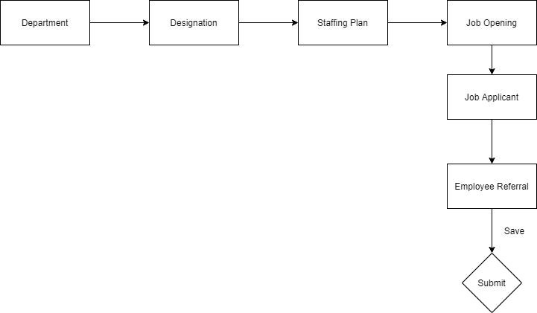

6.14.6 Use case
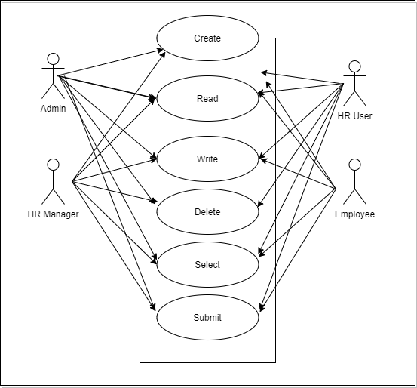

6.14.7 Form Elaboration
SL No. | Label | Type | Mandatory | Options
1 | First Name | Data | 1
2 | Last Name | Data | 1
3 | Full Name | Data | 0
4 |  | Column Break | 0
5 | Date | Date | 1
6 | Status | Select | 1 | Pending  In Process  Accepted  Rejected
7 | For Designation | Link | 1 | Designation
8 | Referral Details | Section Break | 0
9 | Email | Data | 1 | Email
10 | Contact No. | Data | 0 | Phone
11 | Resume Link | Data | 0
12 |  | Column Break | 0
13 | Current Employer | Data | 0
14 | Current Job Title | Data | 0
15 | Resume | Attach | 0
16 | Referrer Details | Section Break | 0
17 | Referrer | Link | 1 | Employee
18 | Referrer Name | Data | 0
19 |  | Column Break | 0
20 | Is Applicable for Referral Bonus | Check | 0
21 | Referral Bonus Payment Status | Select | 0 | Unpaid  Paid
22 | Department | Link | 0 | Department
23 | Additional Information | Section Break | 0
24 | Why is this Candidate Qualified for this Position? | Text Editor | 0
25 | Work References | Text Editor | 0
26 | Amended From | Link | 0 | Employee Referral

6.14.8 Screen Authorization
Sl No. | Role | Level | Select | Read | Write | Create | Delete | Submit
1 | Admin | 0 | 1 | 1 | 1 | 1 | 1 | 1
2 | HR Manager | 0 | 1 | 1 | 1 | 1 | 1 | 1
3 | HR User | 0 | 1 | 1 | 1 | 1 | 1 | 1
4 | Employee | 0 | 1 | 1 | 1 | 1 | 0 | 1
5 | HR Manager | 1 | 0 | 1 | 1 | 0 | 1 | 0
6 | HR User | 1 | 0 | 1 | 1 | 0 | 1 | 0
7 | Employee | 1 | 0 | 1 | 0 | 0 | 0 | 0

6.14.9 Component And Module
Module Related:- HR

6.14.10 Business Logic

1) Go to Employee Referral, click on New.

2) Fill in basic details of the person you want to refer like First Name,Last Name,Email,etc..

3) Select Employee under Referrer.

4) Save and Submit.

6.14.11 Path of the screen
Home > Human Resources > Recruitment > Employee Referral

6.15 Interview Type

6.15.1 Overview

Interview type consist list of different type of interview like Technical Interview,HR Interview and so on.

6.15.2 Description of Problem
Create a form to collect the list of different interview types with description.

6.15.3 Dependency
No Dependency

6.15.4 A Table of Contents
1) Main Table:- TabInterview Type

6.15.5 Flow Chart

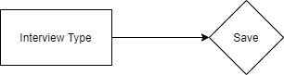

6.15.6 Use case
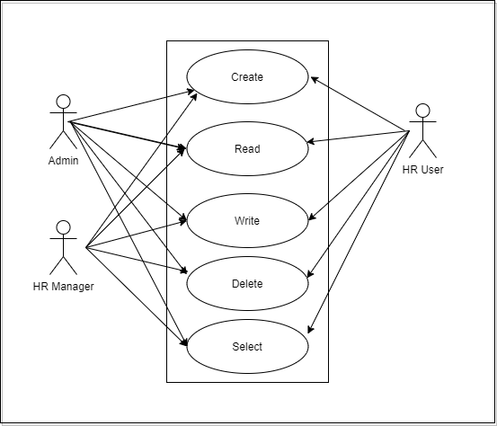

6.15.7 Form Elaboration
SL No. | Label | Type | Mandatory
1 | Name | Data | 1
2 | Description | Text | 0

6.15.8 Screen Authorization
Sl No. | Role | Level | Select | Read | Write | Create | Delete | Submit
1 | Admin | 0 | 1 | 1 | 1 | 1 | 1 | 1
2 | HR Manager | 0 | 1 | 1 | 1 | 1 | 1 | 1
3 | HR User | 0 | 1 | 1 | 1 | 1 | 1 | 1

6.15.9 Component And Module
Module Related:- HR

6.15.10 Business Logic

1) Go to Interview Type, click on New.

2) Fill in the type of Interview and description.

3) Save.

6.15.11 Path of the screen
Home > Human Resources > Recruitment > Interview Type

6.16 Interview Round

6.16.1 Overview

Interview type consist list of different type of interview round like Technical round,HR round and so on.

6.16.2 Description of Problem
Create a form to collect information of Interview Round like round name,designation,interview type,Interviewers and so on.

6.16.3 Dependency
Before creating an Interview Round, it is advisable you create the following documents:
1)Employee
2)Designation
3)Skills
4)Interview Type

6.16.4 A Table of Contents
1) Main Table:- TabInterview Round
2)Child Table:-TabExpected Skill Set

6.16.5 Flow Chart

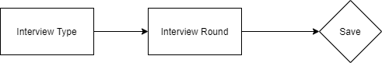

6.16.6 Use case
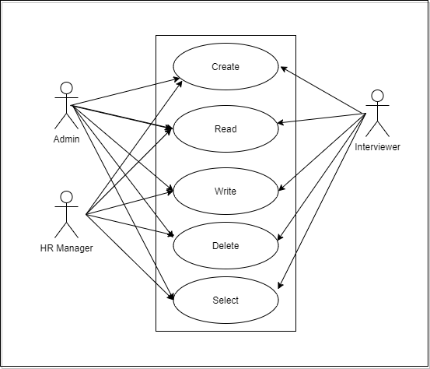

6.16.7 Form Elaboration
SL No. | Label | Type | Mandatory | Options
1 | Round Name | Data | 1
2 | Interview Type | Link | 1 | Interview Type
3 | Interviewers | Table MultiSelect | 0 | Interviewer
4 |  | Column Break | 0
5 | Designation | Link | 0 | Designation
6 | Expected Average Rating | Rating | 1
7 | Expected Skillset | Section Break | 0
8 |  | Table | 1 | Expected Skill Set

6.16.8 Screen Authorization
Sl No. | Role | Level | Select | Read | Write | Create | Delete | Submit
1 | Admin | 0 | 1 | 1 | 1 | 1 | 1 | 0
2 | HR Manager | 0 | 1 | 1 | 1 | 1 | 1 | 0
3 | Interviewer | 0 | 1 | 1 | 1 | 1 | 1 | 0

6.16.9 Component And Module
Module Related:- HR

6.16.10 Business Logic

1) Go to Interview Round, click on New.

2) Fill in the details like Round Name,Designation,Expected Average Rating,Interviewers and select Interview type.

3) Select the different Skill Set.

4) Save

6.16.11 Path of the screen
Home > Human Resources > Recruitment > Interview Round

6.17 Interview

6.17.1 Overview

Interview consist list of interview scheduled for a particular Job Applicant for different interview round. like Technical.

6.17.2 Description of Problem
Create a form to collect information like Interview Round,Job Applicant,Resume link and Feedback from interviewers and schedule the interview for an applicant.

6.17.3 Dependency
Before creating an Interview , it is advisable you create the following documents:
1)Employee
2)Interview Round
3)Job Applicant

6.17.4 A Table of Contents
1) Main Table:- TabInterview
2)Child Table:-TabInterview Table

6.17.5 Flow Chart

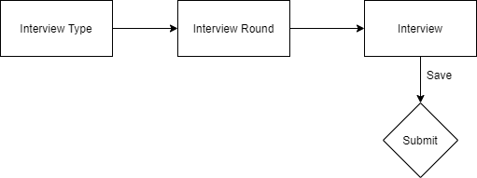

6.17.6 Use case
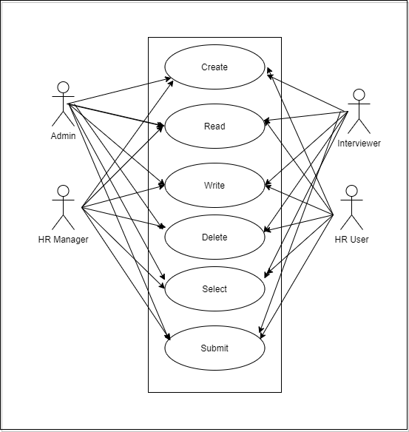

6.17.7 Form Elaboration
SL No. | Label | Type | Mandatory | Options
1 | Details | Section Break | 0
2 | Interview Round | Link | 1 | Interview Round
3 | Job Applicant | Link | 1 | Job Applicant
4 | Job Opening | Link | 0 | Job Opening
5 | Designation | Link | 0 | Designation
6 | Resume link | Data | 0
7 |  | Column Break | 0
8 | Status | Select | 1 | Pending  Under Review  Cleared  Rejected
9 | Scheduled On | Date | 1
10 | From Time | Time | 1
11 | To Time | Time | 1
12 | Feedback | Section Break | 0
13 |  | Table | 0 | Interview Detail
14 | Ratings | Section Break | 0
15 | Expected Average Rating | Rating | 0
16 |  | Column Break | 0
17 | Obtained Average Rating | Rating | 0
18 | Interview Summary | Section Break | 0
19 |  | Text | 0
20 | Reminded | Check | 0
21 | Amended From | Link | 0 | Interview

6.17.8 Screen Authorization
Sl No. | Role | Level | Select | Read | Write | Create | Delete | Submit
1 | Admin | 0 | 1 | 1 | 1 | 1 | 1 | 1
2 | HR Manager | 0 | 1 | 1 | 1 | 1 | 1 | 1
3 | Interviewer | 0 | 1 | 1 | 1 | 1 | 1 | 1
4 | HR User | 0 | 1 | 1 | 1 | 1 | 1 | 1

6.17.9 Component And Module
Module Related:- HR

6.17.10 Business Logic

1) Go to Interview, click on New.

2) Fill in the details like Interview,Job Applicant(all the information like first name,last name,address will be fetched with respect to the Job Applicant id) and feedback from interviewer.

3) Change the status according to the Rating an Result

4) Save and Submit

6.17.11 Path of the screen
Home > Human Resources > Recruitment > Interview

6.18 Job Offer

6.18.1 Overview

Job Offer is given to selected candidates after interview and selection which states the offered salary package, designation, grade, department, number of days entitled for leave among other information.

6.18.2 Description of Problem
Create a form to create a Job Offer for a selected Job Applicant with the information like details of job applicant,Job Offer Terms,Terms and Conditions and so on.

6.18.3 Dependency
Before creating an Job Offer , it is advisable you create the following documents:
1)Staffing Plan
2)Job Opening
3)Job Applicant
4)Interview

6.18.4 A Table of Contents
1) Main Table:- TabJob Offer
2)Child Table:-TabJob Offer Term

6.18.5 Flow Chart

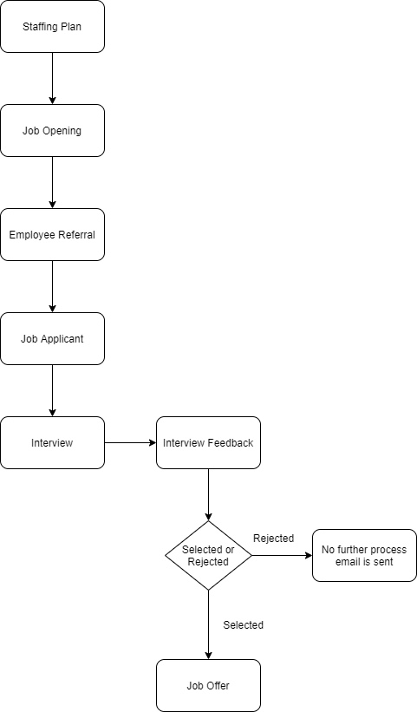

6.18.6 Use case
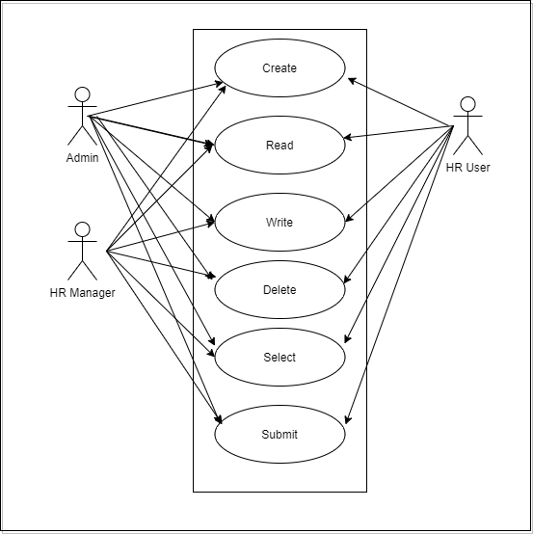

6.18.7 Form Elaboration
SL No. | Label | Type | Mandatory | Options
1 | Job Applicant | Link | 1 | Job Applicant
2 | Applicant Name | Data | 1
3 | Applicant Email Address | Data | 0 | Email
4 |  | Column Break | 0
5 | Status | Select | 0 | Awaiting Response  Accepted  Rejected
6 | Offer Date | Date | 1
7 | Designation | Link | 1 | Designation
8 | Company | Link | 1 | Company
9 |  | Section Break | 0
10 | Job Offer Terms | Table | 0 | Job Offer Term
11 |  | Section Break | 0
12 | Select Terms and Conditions | Link | 0 | Terms and Conditions
13 | Terms and Conditions | Text Editor | 0
14 | Printing Details | Section Break | 0
15 | Letter Head | Link | 0 | Letter Head
16 |  | Column Break | 0
17 | Print Heading | Link | 0 | Print Heading
18 | Amended From | Link | 0 | Job Offer

6.18.8 Screen Authorization
Sl No. | Role | Level | Select | Read | Write | Create | Delete | Submit
1 | Admin | 0 | 1 | 1 | 1 | 1 | 1 | 1
2 | HR Manager | 0 | 1 | 1 | 1 | 1 | 1 | 1
4 | HR User | 0 | 1 | 1 | 1 | 1 | 1 | 1

6.18.9 Component And Module
Module Related:- HR

6.18.10 Business Logic

1) Go to Job Offer, click on New.

2) Select the Job Applicant,Offer Date and Designation.

3) Set the Status of the Job Offer(Awaiting Response,Accepted,Rejected).

4) Save and Submit

6.18.11 Path of the screen
Home > Human Resources > Recruitment > Job Offer

6.19 Appointment Letter Template

6.19.1 Overview

Appointment Letter Template consist of list of appointment letter structure for different designation and department.

6.19.2 Description of Problem
Create a form to create a template for an appointment letter for different designation and department.

6.19.3 Dependency
Before creating an Appointment Letter Template , it is advisable you create the following documents:
1)Department
2)Designation

6.19.4 A Table of Contents
1) Main Table:- TabAppointment Letter Template
2)Child Table:-TabAppointment Letter Content

6.19.5 Flow Chart

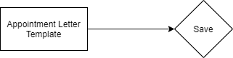

6.19.6 Use case
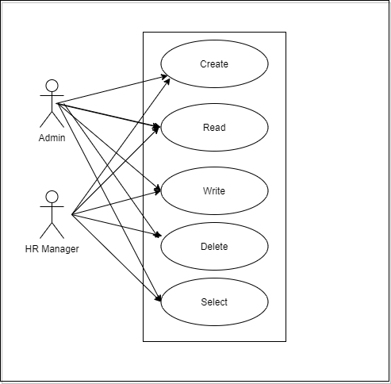

6.19.7 Form Elaboration
SL No. | Label | Type | Mandatory | Options
1 | Template Name | Data | 1
2 | Introduction | Long Text | 1
3 | Terms | Table | 1 | Appointment Letter content
4 | Closing Notes | Text | 0

6.19.8 Screen Authorization
Sl No. | Role | Level | Select | Read | Write | Create | Delete | Submit
1 | Admin | 0 | 1 | 1 | 1 | 1 | 1 | 0
2 | HR Manager | 0 | 1 | 1 | 1 | 1 | 1 | 0

6.19.9 Component And Module
Module Related:- HR

6.19.10 Business Logic

1) Go to an Appointment Letter Template list, click on New.

2) Fill in the Template name,Introduction,Terms and Closing Notes.

3) Save

6.19.11 Path of the screen
Home > Human Resources > Recruitment > Appointment Letter Template

6.20 Appointment Letter

6.20.1 Overview

Appointment Letter is the letter written by the employer requesting the selected candidates to join in a specific position.

6.20.2 Description of Problem
Create an Appointment Letter that you can give to candidates.

6.20.3 Dependency
Before creating an Appointment Letter , it is advisable you create the following documents:
1)Job Applicant

6.20.4 A Table of Contents
1) Main Table:- TabAppointment Letter
2)Child Table:-TabAppointment Letter Content

6.20.5 Flow Chart
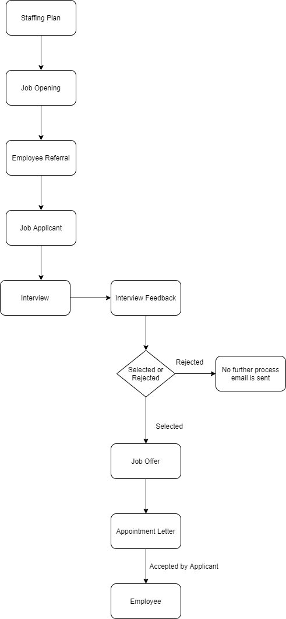

6.20.6 Use case

6.20.7 Form Elaboration
SL No. | Label | Type | Mandatory | Options
1 | Job Applicant | Link | 1 | Job Applicant
2 | Applicant Name | Data | 1
3 |  | Column Break | 0
4 | Company | Link | 1 | Company
5 | Appointment Date | Date | 1
6 | Appointment Letter Template | Link | 1 | Appointment Letter Template
7 | Body | Section Break | 0
8 | Introduction | Long Text | 1
9 | Terms | Table | 1 | Appointment Letter content
10 | Closing Notes | Text | 0

6.20.8 Screen Authorization
Sl No. | Role | Level | Select | Read | Write | Create | Delete | Submit
1 | Admin | 0 | 1 | 1 | 1 | 1 | 1 | 0
2 | HR Manager | 0 | 1 | 1 | 1 | 1 | 1 | 0

6.20.9 Component And Module
Module Related:- HR

6.20.10 Business Logic

1) Go to an Appointment Letter list,click on New.

2) Select the Job Applicant and Appointment Date.

3) You can manually fill Introduction, Terms and, Closing Statement or select an Appointment Letter Template to auto-fill the content. You can create new Appointment Letter Templates to select them easily.

4) Save.

5) After saving, go to the Print View to view and save the PDF of the Appointment letter.

6.20.11 Path of the screen
Home > Human Resources > Recruitment > Appointment Letter

6.21 Employee On-boarding Template

6.21.1 Overview

Employee On-boarding Template consist of list of different Employee On-boarding Template for different designation and department containing list set of standard activities which need to be executed during the process of Employee hiring.

6.21.2 Description of Problem
Create Template containing set of activities along with user and duration.

6.21.3 Dependency
Before creating an Employee On-boarding Template , it is advisable you create the following documents:
1)Department
2)Designation
3)Employee Grade

6.21.4 A Table of Contents
1) Main Table:- TabEmployee Onboarding Template
2)Child Table:-TabEmployee Boarding Activity

6.21.5 Flow Chart

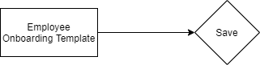

6.21.6 Use case

6.21.7 Form Elaboration
SL No. | Label | Type | Mandatory | Options
1 | Company | Link | 0 | Company
2 | Department | Link | 0 | Department
3 |  | Column Break
4 | Designation | Link | 0 | Designation
5 | Employee Grade | Link | 0 | Employee Grade
6 | Activities | Section Break
7 | Activities | Table | 0 | Employee Boarding Activity

6.21.8 Screen Authorization
Sl No. | Role | Level | Select | Read | Write | Create | Delete | Submit
1 | Admin | 0 | 1 | 1 | 1 | 1 | 1 | 0
2 | HR Manager | 0 | 1 | 1 | 1 | 1 | 1 | 0

6.21.9 Component And Module
Module Related:- HR

6.21.10 Business Logic

1) Go to Employee Onboarding Template,click on New.

2) Select the Designation,Department,Employee Grade.

3) Enter the Activities required for Onboarding process.

4) Save.

6.21.11 Path of the screen
Home > Human Resources > Employee Lifecycle > Employee Onboarding Template

6.22 Employee On-boarding

6.22.1 Overview

In the process of hiring an Employee, there are set of standard activities which need to be executed. This feature helps you to maintain the masters of these activities, and create a set of tasks at the time of each Employee hiring.

6.22.2 Description of Problem
Create a form which consist of list of activities conducted during Employee hiring with respect to the Department and Designation for an Employee (selected Job Applicant).It also contain information like Employee details.

6.22.3 Dependency
Before creating an Employee On-boarding , it is advisable you create the following documents:
1)Department
2)Designation
3)Employee Onboarding Template
4)Employee
5)Job Applicant

6.22.4 A Table of Contents
1) Main Table:- TabEmployee Onboarding
2)Child Table:-TabEmployee Boarding Activity

6.22.5 Flow Chart
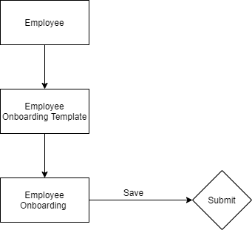

6.22.6 Use case

6.22.7 Form Elaboration
SL No. | Label | Type | Mandatory | Options
1 | Job Applicant | Link | 1 | Job Applicant
2 | Job Offer | Link | 1 | Job Offer
3 | Employee Onboarding Template | Link | 0 | Employee Onboarding Template
4 |  | Column Break
5 | Company | Link | 1 | Company
6 | Status | Select | 0 | Pending  In Process  Completed
7 | Project | Link | 0 | Project
8 | Employee Details | Section Break
9 | Employee | Link | 0 | Employee
10 | Employee Name | Data | 1
11 | Department | Link | 0 | Department
12 | Designation | Link | 0 | Designation
13 | Employee Grade | Link | 0 | Employee Grade
14 | Holiday List | Link | 0 | Holiday List
15 |  | Column Break
16 | Date of Joining | Date | 1
17 | Onboarding Begins On | Date | 1
18 | Onboarding Activities | Section Break
19 | Activities | Table | 0 | Employee Boarding Activity
20 | Notify users by email | Check | 0
21 | Amended From | Link | 0 | Employee Onboarding

6.22.8 Screen Authorization
Sl No. | Role | Level | Select | Read | Write | Create | Delete | Submit
1 | Admin | 0 | 1 | 1 | 1 | 1 | 1 | 1
2 | HR Manager | 0 | 1 | 1 | 1 | 1 | 1 | 1
3 | HR User | 0 | 1 | 1 | 1 | 1 | 1 | 1

6.22.9 Component And Module
Module Related:- HR

6.22.10 Business Logic

1) Go to Employee Onboarding ,click on New.

2) Select the Job Applicant,corresponding Employee details will automatically get fetched.

3) Select the Employee Onboarding Template.Based on the template all information will be fetched.

4) Enter the Joining Date

5) Save and Submit.

6.22.11 Path of the screen
Home > Human Resources > Employee Lifecycle > Employee Onboarding

6.23 Employee Skill Map

6.23.1 Overview
Employee Skill Map is a record which helps your organization track your Employee's skill sets and training. It can be used to rate each skill of the Employee and track their growth after each internal training. This data can be used at the time of appraisals.

6.23.2 Description of Problem
Create a form to record skills and training of an employee along with the information like Skill,Proficiency,Training,Training Date.

6.23.3 Dependency
Before creating an Employee Skill Map , it is advisable you create the following documents:
1)Employee

6.23.4 A Table of Contents
1) Main Table:- TabEmployee Skill Map
2)Child Table:-1)TabEmployee Skill
2)TabEmployee Training

6.23.5 Flow Chart

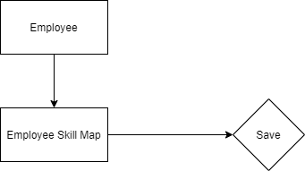

6.23.6 Use case
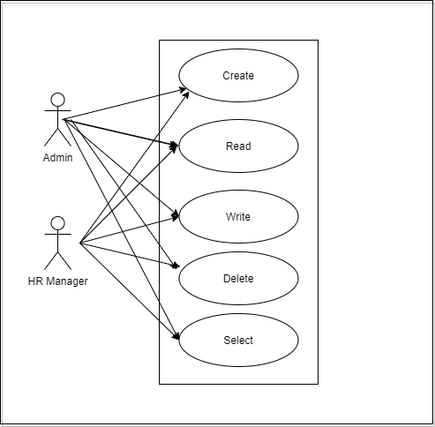

6.23.7 Form Elaboration
SL No. | Label | Type | Mandatory | Options
1 | Employee | Link | 0 | Employee
2 | Employee Name | Read Only | 0
3 |  | Column Break
4 | Designation | Read Only | 0
5 | Skills | Section Break
6 | Employee Skills | Table | 0 | Employee Skill
7 | Trainings | Section Break
8 | Trainings | Table | 0 | Employee Training

6.23.8 Screen Authorization
Sl No. | Role | Level | Select | Read | Write | Create | Delete | Submit
1 | Admin | 0 | 1 | 1 | 1 | 1 | 1 | 0
2 | HR Manager | 0 | 1 | 1 | 1 | 1 | 1 | 0

6.23.9 Component And Module
Module Related:- HR

6.23.10 Business Logic

1) Go to Employee Skill Map ,click on New.

2) Select the Employee

3) All the details of the Employee will be fetched like First name,Last name,department,designation and so on.

4) Based on the Designation of the Employee the Skills will be fetched.Set the Proficiency level(Rating).

5) Under Trainings table,set the training event and date.

6)Save.

6.23.11 Path of the screen
Home > Human Resources > Employee Lifecycle > Employee Skill Map

6.24 Employee Promotion

6.24.1 Overview
Employee Promotion is a process through which an Employee of a company is given a higher share of duties,a higher pay-scale or both.

6.24.2 Description of Problem
Create a form to record the details of Employee Promotion like Employee Details,promotion date and employee promotion details like current designation and new designation,current CTC and so on.

6.24.3 Dependency
Before creating an Employee Promotion , it is advisable you create the following documents:
1)Employee
2)Department

6.24.4 A Table of Contents
1) Main Table:- TabEmployee Promotion
2)Child Table:-1)TabEmployee Property History

6.24.5 Flow Chart

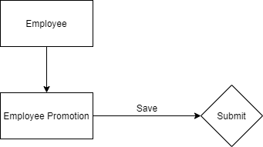

6.24.6 Use case
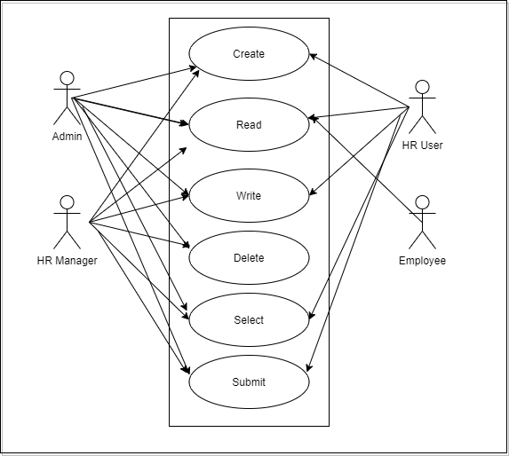

6.24.7 Form Elaboration
SL No. | Label | Type | Mandatory | Options
1 | Employee | Link | 1 | Employee
2 | Employee Name | Data | 0
3 | Department | Link | 0 | Department
4 | Salary Currency | Link | 0 | Currency
5 |  | Column Break
6 | Promotion Date | Date | 1
7 | Company | Link | 0 | Company
8 | Employee Promotion Details | Section Break
9 |  | Table | 1 | Employee Property History
10 | Salary Details | Section Break
11 | Current CTC | Currency | 0
12 |  | Column Break
13 | Revised CTC | Currency | 0
14 | Amended From | Link | 0 | Employee Promotion

6.24.8 Screen Authorization
Sl No. | Role | Level | Select | Read | Write | Create | Delete | Submit
1 | Admin | 0 | 1 | 1 | 1 | 1 | 1 | 1
2 | HR Manager | 0 | 1 | 1 | 1 | 1 | 1 | 1
3 | HR User | 0 | 1 | 1 | 1 | 1 | 0 | 1
4 | Employee | 0 | 0 | 1 | 0 | 0 | 0 | 0

6.24.9 Component And Module
Module Related:- HR

6.24.10 Business Logic

1) Go to Employee Promotion ,click on New.

2) Select the Employee

3) Enter the Promotion Date..

4) In the Employee Promotion Detail table,select the Property and set the Current and New value.

5) Enter the Revised CTC.

6)Save and Submit.

Note: 1.Promotion document can be submitted on or after Promotion Date.

2.After submission of the form,all the changes added in the Promotion Details will be reflected in Employee form.

6.24.11 Path of the screen
Home > Human Resources > Employee Lifecycle > Employee Promotion.

6.25 Employee Transfer

6.25.1 Overview
Employee Promotion is a form of internal mobility, in which the Employee is shifted from one job to another usually at a different location, department, or unit.

6.25.2 Description of Problem
Create a form to record the details of Employee Transfer like Employee Details,transfer date and employee transfer details like current designation and new designation and if required a new employee id is created.

6.25.3 Dependency
Before creating an Employee Transfer , it is advisable you create the following documents:
1)Employee
2)Department

6.25.4 A Table of Contents
1) Main Table:- TabEmployee Transfer
2)Child Table:-1)TabEmployee Property History

6.25.5 Flow Chart

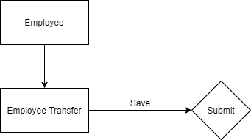

6.25.6 Use case

6.25.7 Form Elaboration
SL No. | Label | Type | Mandatory | Options
1 | Employee | Link | 1 | Employee
2 | Employee Name | Data | 0
3 | Transfer Date | Date | 1
4 |  | Column Break
5 | Company | Link | 0 | Company
6 | New Company | Link | 0 | Company
7 | Department | Link | 0 | Department
8 | Employee Transfer Details | Section Break
9 | Employee Transfer Detail | Table | 1 | Employee Property History
10 | Re-allocate Leaves | Check | 0
11 | Create New Employee Id | Check | 0
12 | New Employee ID | Link | 0 | Employee
13 | Amended From | Link | 0 | Employee Transfer

6.25.8 Screen Authorization
Sl No. | Role | Level | Select | Read | Write | Create | Delete | Submit
1 | Admin | 0 | 1 | 1 | 1 | 1 | 1 | 1
2 | HR Manager | 0 | 1 | 1 | 1 | 1 | 1 | 1
3 | HR User | 0 | 1 | 1 | 1 | 1 | 0 | 1
4 | Employee | 0 | 0 | 1 | 0 | 0 | 0 | 0

6.25.9 Component And Module
Module Related:- HR

6.25.10 Business Logic

1) Go to Employee Transfer ,click on New.

2) Select the Employee

3) Enter the Transfer Date.

4) In the Employee Transfer Detail table,select the Property and set the Current and New value.

5) If required “Create New Employee”checkbox can be checked to create a new Employee Id for the transferred Employee.

6)Save and Submit.

Note: 1.If create new Employee Id is checked,a new Employee will be created with the property changes in Transfer Details table and old Employee will be marked as relieved.

6.25.11 Path of the screen
Home > Human Resources > Employee Lifecycle > Employee Transfer.

6.26 Grievance Type

6.26.1 Overview
Grievance refers to the employee’s dissatisfaction with the company’s work policy and conditions because of an alleged violation of the law like Workplace Harassment.

6.26.2 Description of Problem
Create a form to record of different types of grievances bullying,micromanagement and so on.

6.26.3 Dependency
Before creating an Grievance Type , it is advisable you create the following documents:
1)Employee

6.26.4 A Table of Contents
1) Main Table:- TabGrievance Type

6.26.5 Flow Chart

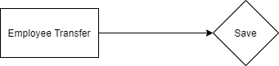

6.26.6 Use case

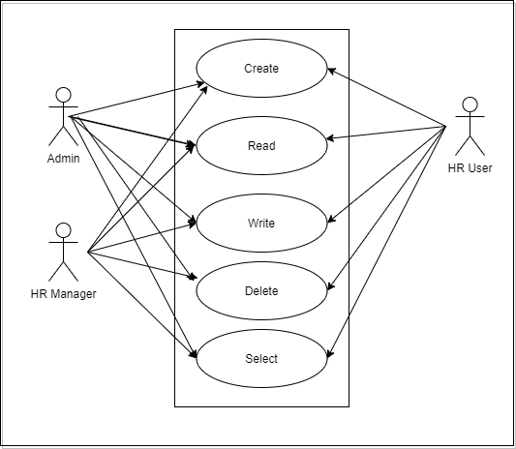

6.26.7 Form Elaboration
SL No. | Label | Type | Mandatory | Options
1 |  | Section Break
2 | Description | Text | 0
3 |  | Section Break
4 | Employee for Investigation | Link | 0 | Employee

6.26.8 Screen Authorization
Sl No. | Role | Level | Select | Read | Write | Create | Delete | Submit
1 | Admin | 0 | 1 | 1 | 1 | 1 | 1 | 0
2 | HR Manager | 0 | 1 | 1 | 1 | 1 | 1 | 0
3 | HR User | 0 | 1 | 1 | 1 | 1 | 1 | 0

6.26.9 Component And Module
Module Related:- HR

6.26.10 Business Logic

1) Go to Grievance Type ,click on New.

2) Enter the Name,Description and Employee for Investigation.

3) Save.

6.26.11 Path of the screen
Home > Human Resources > Employee Lifecycle > Grievance Type

6.27 Employee Grievance

6.27.1 Overview

Employee Grievance is a formal complaint raised by an employee against a fellow employee or manager, or even against the employer. Employees usually file grievances for workplace harassment, discrimination, nepotism, concerns regarding team management or regarding terms of the employment.

6.27.2 Description of Problem

Create a form to record a formal complaint raised by an employee.It will record information like subject,date,raised by whom,status,grievance details like grievance against,grievance type and so on and it will also collect investigation details.

6.27.3 Dependency
Before creating an Employee Grievance , it is advisable you create the following documents:
1)Employee
2)Grievance Type

6.27.4 A Table of Contents
1) Main Table:- TabEmployee Grievance

6.27.5 Flow Chart

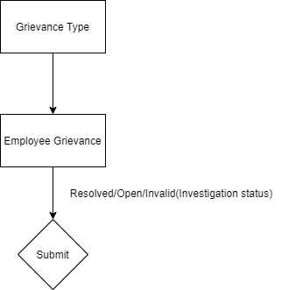

6.27.6 Use case

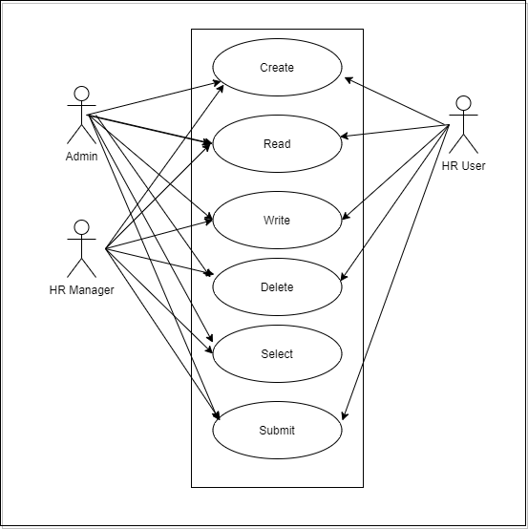

6.27.7 Form Elaboration
SL No. | Label | Type | Mandatory | Options
1 | Subject | Data | 1
2 | Raised By | Link | 1 | Employee
3 | Employee Name | Data | 0
4 | Designation | Link | 0 | Designation
5 |  | Column Break
6 | Date | Date | 1
7 | Status | Select | 1 | Open  Investigated  Resolved  Invalid
8 | Reports To | Link | 0 | Employee
9 | Grievance Details | Section Break
10 | Grievance Against Party | Link | 1 | DocType
11 | Grievance Against | Dynamic Link | 1
12 | Grievance Type | Link | 1 | Grievance Type
13 |  | Column Break
14 | Associated Document Type | Link | 0 | DocType
15 | Associated Document | Dynamic Link | 0
16 |  | Section Break
17 | Description | Text | 1
18 | Investigation Details | Section Break
19 | Cause of Grievance | Text | 0
20 | Resolution Details | Section Break
21 | Resolved By | Link | 0 | User
22 | Resolution Date | Date | 0
23 | Employee Responsible | Link | 0 | Employee
24 |  | Column Break
25 | Resolution Details | Small Text | 0
26 | Amended From | Link | 0 | Employee Grievance

6.27.8 Screen Authorization
Sl No. | Role | Level | Select | Read | Write | Create | Delete | Submit
1 | Admin | 0 | 1 | 1 | 1 | 1 | 1 | 1
2 | HR Manager | 0 | 1 | 1 | 1 | 1 | 1 | 1
3 | HR User | 0 | 0 | 1 | 1 | 1 | 1 | 1

6.27.9 Component And Module
Module Related:- HR

6.27.10 Business Logic

1) Go to Employee Grievance ,click on New.

2) Enter the subject,date,raised by and grievance details.

3) Set the status of the form as Open/Invalid/Resolved/Closed

4)Enter the Investigation details and resolution details

5)Submit

Note: 1.If investigation is completed,change the status to “Resolved”and submit the form.

6.27.11 Path of the screen
Home > Human Resources > Employee Lifecycle > Employee Grievance

6.28 Employee Separation Template

6.28.1 Overview

Employee On-boarding Template consist of list of different Employee Separation Template for different designation and department containing list set of standard activities which need to be executed during the process of Employee exit.

6.28.2 Description of Problem
Create Template containing set of activities along with user and duration.

6.28.3 Dependency
Before creating an Employee On-boarding Template , it is advisable you create the following documents:
1)Department
2)Designation
3)Employee Grade
4)Employee

6.28.4 A Table of Contents
1) Main Table:- TabEmployee Separation Template
2)Child Table:-TabEmployee Boarding Activity

6.28.5 Flow Chart
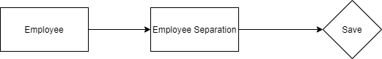

6.28.6 Use case

6.28.7 Form Elaboration
SL No. | Label | Type | Mandatory | Options
1 | Company | Link | 0 | Company
2 | Department | Link | 0 | Department
3 |  | Column Break
4 | Designation | Link | 0 | Designation
5 | Employee Grade | Link | 0 | Employee Grade
6 | Activities | Section Break
7 | Activities | Table | 0 | Employee Boarding Activity

6.28.8 Screen Authorization
Sl No. | Role | Level | Select | Read | Write | Create | Delete | Submit
1 | Admin | 0 | 1 | 1 | 1 | 1 | 1 | 0
2 | HR Manager | 0 | 1 | 1 | 1 | 1 | 1 | 0

6.28.9 Component And Module
Module Related:- HR

6.28.10 Business Logic

1) Go to Employee Separation Template,click on New.

2) Select the Designation,Department,Employee Grade.

3) Enter the Activities required for Separation process.

4) Save.

6.28.11 Path of the screen
Home > Human Resources > Employee Lifecycle > Employee Separation Template

6.29 Employee Separation

6.29.1 Overview

Employee Separation is a situation when the service agreement of an Employee with his/her organization comes to an end and the Employee leaves the organization.

6.29.2 Description of Problem
Create a form to collect the record of Employee separation with the information like Employee(after filling employee id,the employee information like employee name,department and designation will be fetched),activities,separation date and so on.

6.29.3 Dependency
Before creating an Employee Separation, it is advisable you create the following documents:
1)Employee
2)Department
3)Designation
4)Employee Grade

6.29.4 A Table of Contents
1) Main Table:- TabEmployee Separation
2)Child Table:-TabEmployee Boarding Activity

6.29.5 Flow Chart

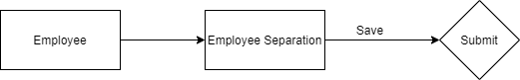

6.29.6 Use case

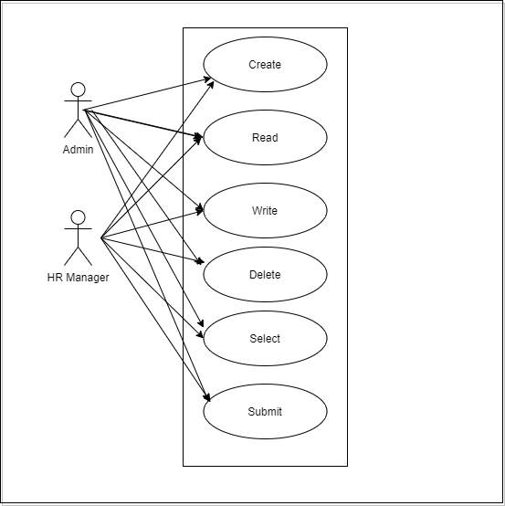

6.29.7 Form Elaboration
SL No. | Label | Type | Mandatory | Options
1 | Employee | Link | 1 | Employee
2 | Employee Name | Data | 0
3 | Department | Link | 0 | Department
4 | Designation | Link | 0 | Designation
5 | Employee Grade | Link | 0 | Employee Grade
6 |  | Column Break | 0
7 | Company | Link | 1 | Company
8 | Status | Select | 0 | Pending  In Process  Completed
9 | Resignation Letter Date | Date | 0
10 | Separation Begins On | Date | 1
11 | Project | Link | 0 | Project
12 | Separation Activities | Section Break | 0
13 | Employee Separation Template | Link | 0 | Employee Separation Template
14 | Activities | Table | 0 | Employee Boarding Activity
15 | Notify users by email | Check | 0
16 |  | Section Break | 0
17 | Exit Interview Summary | Text Editor | 0
18 | Amended From | Link | 0 | Employee Separation

6.29.8 Screen Authorization
Sl No. | Role | Level | Select | Read | Write | Create | Delete | Submit
1 | Admin | 0 | 1 | 1 | 1 | 1 | 1 | 1
2 | HR Manager | 0 | 1 | 1 | 1 | 1 | 1 | 1

6.29.9 Component And Module
Module Related:- HR

6.29.10 Business Logic

1) Go to Employee Separation,click on New.

2) Select the Employee.Once the Employee is selected,the corresponding Employee information such as Department,Designation and Employee Grade will automatically get fetched.

3) Select the Employee Separation Template.Based on the template selected,information such as Designation,Department and Employee grade will be automatically fetched(if already mentioned in the Separation).

4) Enter Resignation Letter Date

5) Save and Submit.

6.29.11 Path of the screen
Home > Human Resources > Employee Lifecycle > Employee Separation

6.30 Leave Type

6.30.1 Overview

Leave Type refers to the types of leaves allocated to an Employee which they can use while making Leave Applications.

6.30.2 Description of Problem
Create a form to collect the list of different type of leaves with information like leave type name,maximum leave allocation allowed,applicable after, maximum consecutive leaves allowed and so on.
Below is a detailed explanation of different check-boxes(validation):
Max Leaves Allowed: This field allows you to set the maximum number of the annual allocation of this Leave Type while creating the Leave Policy.
Applicable After (Working Days): Enter the minimum number of working days here. Only the employees who have worked for this number of days or more will be allowed to apply for this particular leave type. Any other leaves (such as Casual Leave, Sick Leave.etc.) availed by the Employees after their joining date will also be considered while calculating working days of the Employee.
Maximum Continuous Days Applicable: It refers to the maximum number of days this particular Leave Type can be availed at a stretch. If an employee exceeds the maximum number of days, their extended leave will be considered as ‘Leave Without Pay'.
Is Carry Forward: If checked, the balance leaves of this Leave Type will be carried forward to the next allocation period.
Is Leave Without Pay: This ensures that the Leave Type will be treated as leaves without pay and salary will get deducted for this Leave Type.
Is Optional: Optional Leaves are holidays that Employees can choose to avail from a
list of holidays published by the company. The Holiday List for Optional Leaves can have any number of holidays, but you can restrict the number of such leaves by setting the Max Days Leave Allowed field.
Allow Negative Balance: If checked, the system will always allow to apply and approve Leave Applications for the Leave Type, even if there is no leave balance.
Allow Over Allocation: If checked, the system will allow allocating more leaves than the number of days in the allocation period.
Include holidays within leaves as leaves: Check this option if you wish to count holidays within leaves as a ‘leave’. For example, if an Employee has applied for leave on Friday and Monday, and Saturday and Sunday are weekly offs, if the 'Include holidays within leaves as leaves' checkbox for the Leave Type is checked, the system will consider Saturday as Sunday as leaves too. Such holidays will be deducted from the total number of leaves.
Is Compensatory: Compensatory leaves are leaves granted for working overtime or on holidays, normally compensated as an encashable leave. You can check this option to mark the Leave Type as compensatory. An Employee can request for compensatory leaves using Compensatory Leave Request.

Leave Encashment: It is possible that Employees can receive cash from their Employer for unused leaves granted to them in a Leave Period. Not all Leave Types need to be encashable, so, you should set "Allow Encashment" for only those Leave Types which are encashable.

6.30.3 Dependency
No Dependency.

6.30.4 A Table of Contents
1) Main Table:- TabLeave Type

6.30.5 Flow Chart

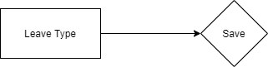

6.30.6 Use case

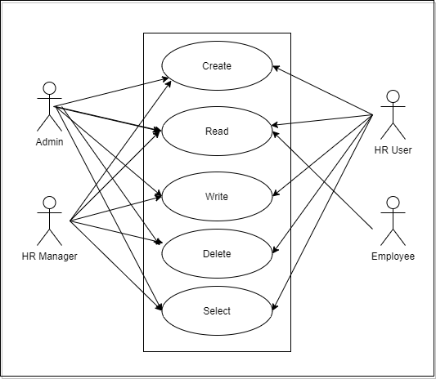

6.30.7 Form Elaboration
SL No. | Label | Type | Mandatory | Options
1 | Leave Type Name | Data | 1
2 | Maximum Leave Allocation Allowed | Int | 0
3 | Applicable After (Working Days) | Int | 0
4 | Maximum Consecutive Leaves Allowed | Int | 0
5 |  | Column Break | 0
6 | Is Carry Forward | Check | 0
7 | Is Leave Without Pay | Check | 0
8 | Is Partially Paid Leave | Check | 0
9 | Fraction of Daily Salary per Leave | Float | 0
10 | Is Optional Leave | Check | 0
11 | Allow Negative Balance | Check | 0
12 | Allow Over Allocation | Check | 0
13 | Include holidays within leaves as leaves | Check | 0
14 | Is Compensatory | Check | 0
15 | Carry Forward | Section Break | 0
16 | Maximum Carry Forwarded Leaves | Float | 0
17 | Expire Carry Forwarded Leaves (Days) | Int | 0
18 | Encashment | Section Break | 0
19 | Allow Encashment | Check | 0
20 | Encashment Threshold Days | Int | 0
21 |  | Column Break | 0
22 | Earning Component | Link | 0 | Salary Component
23 | Earned Leave | Section Break | 0
24 | Is Earned Leave | Check | 0
25 | Earned Leave Frequency | Select | 0 | Monthly  Quarterly  Half-Yearly  Yearly
26 |  | Column Break | 0
27 | Based On Date Of Joining | Check | 0
28 | Rounding | Select | 0 | 0.25  0.5  1.0

6.30.8 Screen Authorization
Sl No. | Role | Level | Select | Read | Write | Create | Delete | Submit
1 | Admin | 0 | 1 | 1 | 1 | 1 | 1 | 0
2 | HR Manager | 0 | 1 | 1 | 1 | 1 | 1 | 0
3 | HR User | 0 | 1 | 1 | 1 | 1 | 1 | 0
4 | Employee | 0 | 0 | 1 | 0 | 0 | 0 | 0

6.30.9 Component And Module
Module Related:- HR,Finance,Payroll

6.30.10 Business Logic

1) Go to Leave Type,click on New.

2) Enter LEave Type Name.

3) Enter maximum leave allowed,applicable after(working days),maximum continuous days applicable.

4) Check the options as the requirement like Is Leave Without Pay and so on.

5) Save

6.30.11 Path of the screen
Home > Human Resources > Leaves > Leave Type

6.31 Leave Period

6.31.1 Overview

Leave Period refers to the duration of time for which leaves are allocated.

6.31.2 Description of Problem
Create a form to collect the information regarding the leave duration.It will consist of Start date,End date,Holiday list and so on.

6.31.3 Dependency
Before creating a Leave Period, it is advisable you create the following documents:
1)Holiday Lists
2)Company

6.31.4 A Table of Contents
1) Main Table:- TabLeave Period

6.31.5 Flow Chart

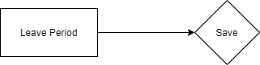

6.31.6 Use case
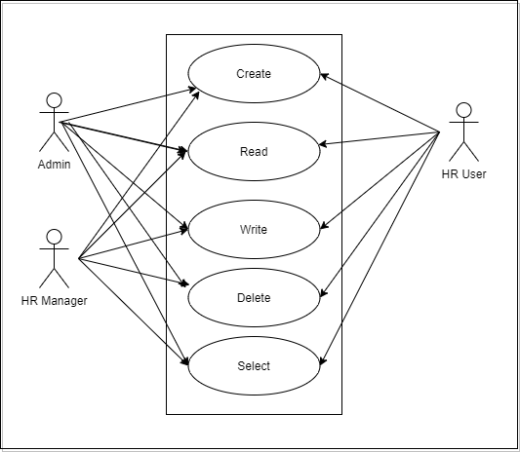

6.31.7 Form Elaboration
SL No. | Label | Type | Mandatory | Options
1 | From Date | Date | 1
2 | To Date | Date | 1
3 | Is Active | Check | 0
4 |  | Column Break | 0
5 | Company | Link | 1 | Company
6 | Holiday List for Optional Leave | Link | 0 | Holiday List

6.31.8 Screen Authorization
Sl No. | Role | Level | Select | Read | Write | Create | Delete | Submit
1 | Admin | 0 | 1 | 1 | 1 | 1 | 1 | 0
2 | HR Manager | 0 | 1 | 1 | 1 | 1 | 1 | 0
3 | HR User | 0 | 1 | 1 | 1 | 1 | 1 | 0

6.31.9 Component And Module
Module Related:- HR,Finance,Payroll

6.31.10 Business Logic

1) Go to Leave Period list,click on New.

2) Enter the From Date and To Date of the Leave Period.

3) Select the company nae for which the Leave Period is applicable.

4) Save

Note:1.The 'Holiday List for Optional Leaves' is not the same as the usual 'Holiday List'. This list will contain a list of optional holidays only. 'Holiday List for Optional Leaves' can be created from the Holiday List document. You can create two Holiday Lists for a Leave Period; one containing the usual set of holidays and the other for optional holidays.

6.31.11 Path of the screen
Home > Human Resources > Leaves > Leave Period

6.32 Leave Policy

6.32.1 Overview

Leave Policy is referred to the amount of entitled leaves in a Company for an Employee in a Leave Period .

6.32.2 Description of Problem
Create a form to collect the information regarding Leave Policy Details like leave type and annual allocation.

6.32.3 Dependency
Before creating a Leave Policy, it is advisable you create the following documents:
- Leave type

6.32.4 A Table of Contents
1) Main Table:- TabLeave Policy
2) Child Table:- Tab Policy Detail

6.32.5 Flow Chart

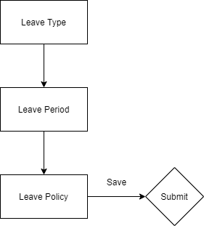

6.32.6 Use case
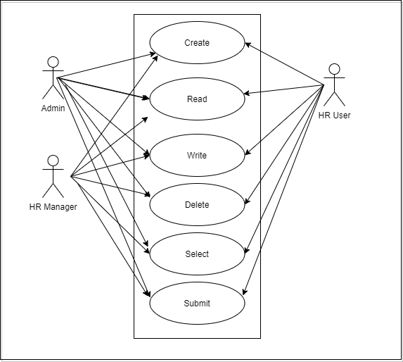

6.32.7 Form Elaboration
SL No. | Label | Type | Mandatory | Options
1 | Title | Data | 1
2 | Leave Allocations | Section Break | 0
3 | Leave Policy Details | Table | 1 | Leave Policy Detail
4 | Amended From | Link | 0 | Leave Policy

6.32.8 Screen Authorization
Sl No. | Role | Level | Select | Read | Write | Create | Delete | Submit
1 | Admin | 0 | 1 | 1 | 1 | 1 | 1 | 1
2 | HR Manager | 0 | 1 | 1 | 1 | 1 | 1 | 1
3 | HR User | 0 | 1 | 1 | 1 | 1 | 1 | 1

6.32.9 Component And Module
Module Related:- HR,Finance,Payroll

6.32.10 Business Logic

1) Go to Leave Policy list,click on New.

2) Select the Leave Type and enter its Annual Allocation.

3) Save and Submit.

Note:1.Once submitted, you can enforce the Leave Policy through the dashboard, either to an Employee or an Employee Grade.

6.32.11 Path of the screen
Home > Human Resources > Leaves > Leave Policy

6.33 Leave Policy Assignment

6.33.1 Overview

Leave Policy Assignment is used to assign leaves to employees based on created policies.

6.33.2 Description of Problem
Create a form to allocate a Leave Policy to an Employee.It will collect information like Employee id(on selecting employee id,employee name,designation will be fetched),leave policy ,assignment based on(Leave Period/Joining Date),effective from and so on.

6.33.3 Dependency
Before creating a Leave Policy Assignment, it is advisable you create the following documents:
- Employee
- Leave Policy
- Leave Period

6.33.4 A Table of Contents
1) Main Table:- TabLeave Policy Assignment

6.33.5 Flow Chart
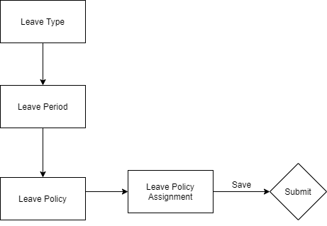

6.33.6 Use case

6.33.7 Form Elaboration
SL No. | Label | Type | Mandatory | Options
1 | Employee | Link | 1 | Employee
2 | Employee name | Data | 0
3 | Company | Link | 0 | Company
4 | Leave Policy | Link | 1 | Leave Policy
5 | Add unused leaves from previous allocations | Check | 0
6 |  | Column Break | 0
7 | Assignment based on | Select | 0 | Leave Period  Joining Date
8 | Leave Period | Link | 0 | Leave Period
9 | Effective From | Date | 1
10 | Effective To | Date | 1
11 | Leaves Allocated | Check | 0
12 | Amended From | Link | 0 | Leave Policy Assignment

6.33.8 Screen Authorization
Sl No. | Role | Level | Select | Read | Write | Create | Delete | Submit
1 | Admin | 0 | 1 | 1 | 1 | 1 | 1 | 1
2 | HR Manager | 0 | 1 | 1 | 1 | 1 | 1 | 1
3 | HR User | 0 | 1 | 1 | 1 | 1 | 1 | 1

6.33.9 Component And Module
Module Related:- HR,Finance,Payroll

6.33.10 Business Logic

1) Go to Leave Policy list Assignment,click on New.

2) Select Employee and Leave Policy.

3) Select Assignment based on the following as needed:

a)"Assignment based on" is set to Leave Period, you need to select the applicable Leave Period. The Effective From and Effective To dates will be set automatically based on the Leave Period selected.

b)If "Assignment based on" is set to Joining Date, the Effective From date will be set to the employee's Date of Joining.

c)If "Assignment based on" is left blank, then you will have to set the Effective From and Effective To date manually.

4)Save and Submit.

6.33.11 Path of the screen
Home > Human Resources > Leaves > Leave Policy Assignment

6.34 Leave Allocation

6.34.1 Overview

Leave Allocation enables to allocate a specific number of leaves of a particular type to an Employee.

6.34.2 Description of Problem
Create a form to allocate a Leave to an Employee.It will collect information like Employee id(on selecting employee id,employee name,designation will be fetched),leave type,to date and allocation details like New leaves Allocated.
Note: 'Add unused leaves from previous allocations' option in case you want to carry forward unused leaves from the previous allocation period for this particular Leave Type

6.34.3 Dependency
Before creating a Leave Allocation, it is advisable you create the following documents:
1)Employee
2)Leave Policy
3)Leave Period
4)Leave Type

6.34.4 A Table of Contents
1) Main Table:- TabLeave Allocation

6.34.5 Flow Chart
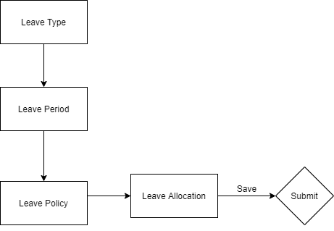

6.34.6 Use case

6.34.7 Form Elaboration
SL No. | Label | Type | Mandatory | Options
1 | Series | Select | 1 | HR-LAL-.YYYY.-
2 | Employee | Link | 1 | Employee
3 | Employee Name | Data | 0
4 | Department | Link | 0 | Department
5 | Company | Link | 1 | Company
6 |  | Column Break | 0
7 | Leave Type | Link | 1 | Leave Type
8 | From Date | Date | 1
9 | To Date | Date | 1
10 | Allocation | Section Break | 0
11 | New Leaves Allocated | Float | 0
12 | Add unused leaves from previous allocations | Check | 0
13 | Unused leaves | Float | 0
14 | Total Leaves Allocated | Float | 1
15 | Total Leaves Encashed | Float | 0
16 |  | Column Break | 0
17 | Compensatory Leave Request | Link | 0 | Compensatory Leave Request
18 | Leave Period | Link | 0 | Leave Period
19 | Leave Policy | Link | 0 | Leave Policy
20 | Leave Policy Assignment | Link | 0 | Leave Policy Assignment
21 | Carry Forwarded Leaves | Float | 0
22 | Expired | Check | 0
23 | Amended From | Link | 0 | Leave Allocation
24 | Notes | Section Break | 0
25 | Description | Small Text | 0

6.34.8 Screen Authorization
Sl No. | Role | Level | Select | Read | Write | Create | Delete | Submit
1 | Admin | 0 | 1 | 1 | 1 | 1 | 1 | 1
2 | HR Manager | 0 | 1 | 1 | 1 | 1 | 1 | 1
3 | HR User | 0 | 1 | 1 | 1 | 1 | 1 | 1

6.34.9 Component And Module
Module Related:- HR,Finance,Payroll

6.34.10 Business Logic

1) Go to Leave Allocation,click on New.

2) Select the Employee,Leave Type,From Date and To Date.

3) Enter the number of New Leaves Allocated for that particular Leave Type.

4)Save and Submit.

6.34.11 Path of the screen
Home > Human Resources > Leaves > Leave Allocation

6.35 Leave Application

6.35.1 Overview

Leave Application is a formal document created by an Employee to apply for Leaves for a particular time period.

6.35.2 Description of Problem
Create a form where employees can apply for leaves.It will consist of information like Employee Id,leave type,from date,to date, leave approver and so on.

Note:Below are few key points:
1.On selecting Employee Id,the Leave balance of the employee will be fetched.
2.Concerned Leave Approver details will be fetched once the employee id is selected.

6.35.3 Dependency
Before creating a Leave Application, it is advisable you create the following documents:
1)Department
2)Leave Period
3)Leave Policy
4)Leave Type
5)Leave Allocation
6)Employee

6.35.4 A Table of Contents
1) Main Table:- TabLeave Application

6.35.5 Flow Chart
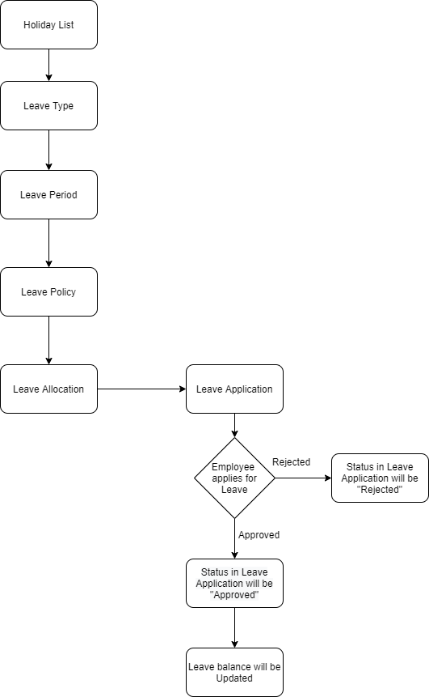

6.35.6 Use case
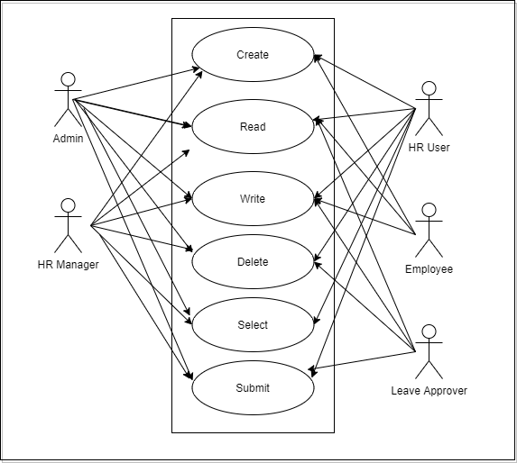

6.35.7 Form Elaboration
SL No. | Label | Type | Mandatory | Options
1 | Series | Select | 1 | HR-LAP-.YYYY.-
2 | Employee | Link | 1 | Employee
3 | Employee Name | Data | 0
4 |  | Column Break | 0
5 | Leave Type | Link | 1 | Leave Type
6 | Department | Link | 0 | Department
7 | Leave Balance Before Application | Float | 0
8 |  | Section Break | 0
9 | From Date | Date | 1
10 | To Date | Date | 1
11 | Half Day | Check | 0
12 | Half Day Date | Date | 0
13 | Total Leave Days | Float | 0
14 |  | Column Break | 0
15 | Reason | Small Text | 0
16 |  | Section Break | 0
17 | Leave Approver | Link | 0 | User
18 | Leave Approver Name | Data | 0
19 |  | Column Break | 0
20 | Status | Select | 1 | Open  Approved  Rejected  Cancelled
21 | Salary Slip | Link | 0 | Salary Slip
22 |  | Section Break | 0
23 | Posting Date | Date | 1
24 | Follow via Email | Check | 0
25 | Color | Color | 0
26 |  | Column Break | 0
27 | Company | Link | 1 | Company
28 | Letter Head | Link | 0 | Letter Head
29 | Amended From | Link | 0 | Leave Application

6.35.8 Screen Authorization
Sl No. | Role | Level | Select | Read | Write | Create | Delete | Submit
1 | Admin | 0 | 1 | 1 | 1 | 1 | 1 | 1
2 | HR Manager | 0 | 1 | 1 | 1 | 1 | 1 | 1
3 | HR User | 0 | 1 | 1 | 1 | 1 | 1 | 1
4 | Employee | 0 | 1 | 1 | 1 | 1 | 0 | 0
5 | Leave Approver | 0 | 1 | 1 | 1 | 0 | 0 | 1
6 | Leave Approver | 1 | 1 | 1 | 0 | 0 | 0 | 0

6.35.9 Component And Module
Module Related:- HR,Finance,Payroll

6.35.10 Business Logic

1) Go to Leave Application,click on New.

2) Select the Employee Name and Leave Type.

3) Set the Leave Duration using From Date and To Date.Based on dates,”Total Leave Days”and “Leave Balance Before Application”field will be displayed.

4)If the Leave applied is for a half-day,select the “Half Day”checkbox.

5)Enter the Reason for Leave.

6)Check the “Follow via Email”checkbox to send notification of the Leave Application to the Leave Approver.

7)Click on “Save”.

Note:1.Once the Employee saves the Leave Application, the status of the Leave Application changes to 'Open', and an email is sent to the Leave Approver for approval.

Note:2Once the Leave Approver receives the email, they can Approve, Reject, or Cancel the Leave Application. Once this is done, the Leave Approver can submit the Leave Application. On submission, the status of the document changes accordingly, and an email is sent to the Employee notifying them the same.

6.35.11 Path of the screen
Home > Human Resources > Leaves > Leave Application

6.36 Leave Block List

6.36.1 Overview
Leave Block List is a list of dates in a year, on which employees cannot apply for leave.

6.36.2 Description of Problem
Create a form to define a list of days to be blocked from taking leaves along with the reason and list of Leave Approvers who can approve Leave Applications on blocked days,in case of urgency.

6.36.3 Dependency
Before creating a Leave Block List, it is advisable you create the following documents:
1)Company
2)Department
3)Leave Period

6.36.4 A Table of Contents
1) Main Table:- TabLeave Block List
2) Child Table:-TabLeave Block List Allow

6.36.5 Flow Chart

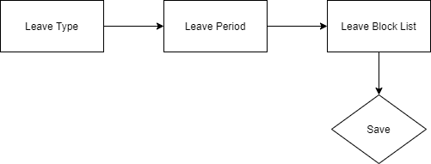

6.36.6 Use case
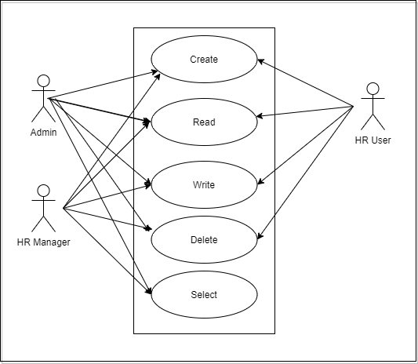

6.36.7 Form Elaboration
SL No. | Label | Type | Mandatory | Options
1 | Leave Block List Name | Data | 1
2 | Company | Link | 1 | Company
3 | Applies to Company | Check | 0
4 |  | Column Break | 0
5 | Leave Type | Link | 0 | Leave Type
6 | Block Days | Section Break | 0
7 | Add Day-wise Dates | Button | 0
8 | Leave Block List Dates | Table | 1 | Leave Block List Date
9 | Allow Users | Section Break | 0
10 | Leave Block List Allowed | Table | 0 | Leave Block List Allow

6.36.8 Screen Authorization
Sl No. | Role | Level | Select | Read | Write | Create | Delete | Submit
1 | Admin | 0 | 1 | 1 | 1 | 1 | 1 | 1
2 | HR Manager | 0 | 1 | 1 | 1 | 1 | 1 | 1
3 | HR User | 0 | 1 | 1 | 1 | 1 | 1 | 1
4 | Employee | 0 | 1 | 1 | 1 | 1 | 0 | 0
5 | Leave Approver | 0 | 1 | 1 | 1 | 0 | 0 | 1
6 | Leave Approver | 1 | 1 | 1 | 0 | 0 | 0 | 0

6.36.9 Component And Module
Module Related:- HR,Finance,Payroll

6.36.10 Business Logic

1) Go to Leave Block list,click on New.

2) Enter Leave Block List Name.

3) Enter Block Date and Reason in the “Leave Block List Dates”table.

4) Enter Users to approve Leave Applications for Blocked Days in the “Leave Block List Allowed”table.

5) Save

Note:1Enable the 'Applies to Company' option if you want the Leave Block List to be applicable for the entire Company. If not checked, the list will have to be added to each Department where it has to be applied.

6.36.11 Path of the screen
Home > Human Resources > Leaves > Leave Block List.

6.37 Compensatory Leave Request

6.37.1 Overview
Compensatory Leave is a leave that is granted to an Employee as compensation for working overtime or on holidays.

6.37.2 Description of Problem
Create a form to collect list of compensatory leave request by employees with the information like employee details,leave type,worked on holiday,reason and so on.

Note: Only Leave Types which are marked as 'Is Compensatory' can be selected in the Compensatory Leave Request.

6.37.3 Dependency
Before creating a Compensatory Leave Request, it is advisable you create the following documents:
1)Employee
2)Leave Period
3)Leave Type
4)Leave Policy
5)Leave Allocation
6)Holiday List
7)Attendance

6.37.4 A Table of Contents
1) Main Table:- TabCompensatory Leave Request

6.37.5 Flow Chart

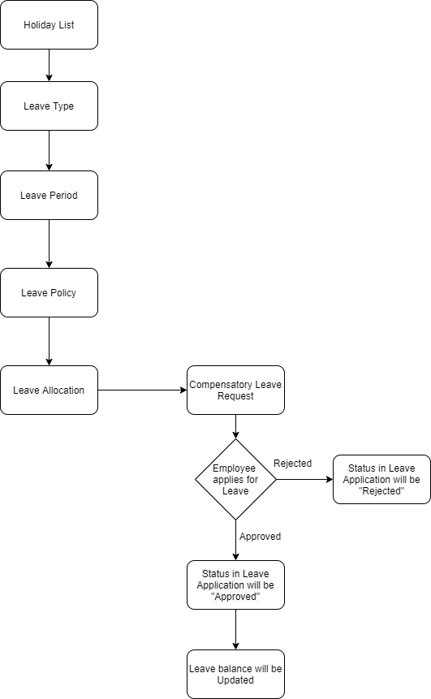

6.37.6 Use case
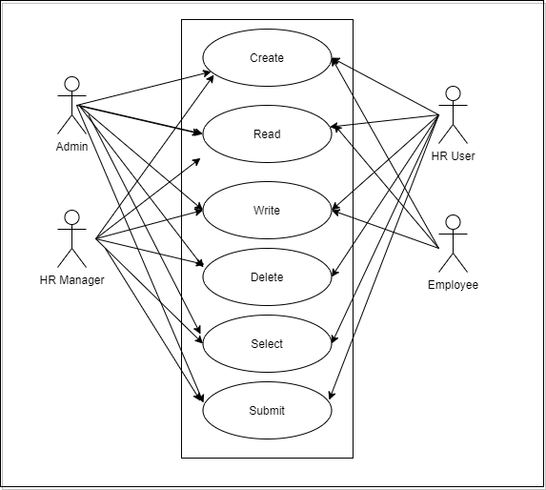

6.37.7 Form Elaboration
SL No. | Label | Type | Mandatory | Options
1 | Employee | Link | 1 | Employee
2 | Employee Name | Data | 0
3 | Department | Link | 0 | Department
4 |  | Column Break | 0
5 | Leave Type | Link | 0 | Leave Type
6 | Leave Allocation | Link | 0 | Leave Allocation
7 | Worked On Holiday | Section Break | 0
8 | Work From Date | Date | 1
9 | Work End Date | Date | 1
10 | Half Day | Check | 0
11 | Half Day Date | Date | 0
12 |  | Column Break | 0
13 | Reason | Small Text | 1
14 | Amended From | Link | 0 | Compensatory Leave Request

6.37.8 Screen Authorization
Sl No. | Role | Level | Select | Read | Write | Create | Delete | Submit
1 | Admin | 0 | 1 | 1 | 1 | 1 | 1 | 1
2 | HR Manager | 0 | 1 | 1 | 1 | 1 | 1 | 1
3 | HR User | 0 | 1 | 1 | 1 | 1 | 1 | 1
4 | Employee | 0 | 1 | 1 | 1 | 1 | 0 | 0

6.37.9 Component And Module
Module Related:- HR,Finance,Payroll

6.37.10 Business Logic

1) Go to Compensatory Leave Request list,click on New.

2) Select the employee id.Once selected,employee name and department will get automatically fetched.

3) Select Leave Type.

4) Select work from date and work end date.This is the date of the day(s) the employee has worked on,during a Holiday

5) Eter the Reason

6 Save and Submit.

Note:1On submitting the Compensatory Leave Request, system updates the Leave Allocation record for the Compensatory leave type, allowing the Employee to apply for leaves of this type later on depending upon the number of leaves left.

6.37.11 Path of the screen
Home > Human Resources > Leaves > Compensatory Leave Request.

6.38 Leave Encashment

6.38.1 Overview
Leave Encashment refers to an amount of money received in exchange for Leaves not availed by an Employee. You can submit Leave Encashment for Leave Types which are encashable.

6.38.2 Description of Problem
Create a form to collect list of Leave Encashment requested by an Employee.It will consist of information like leave period,Employee,payroll details.
Note: As you select Employee and Leave Type, Leave Balance and Encashable Days (which is total leave balance minus the threshold days set in Leave Type) will be shown along with the Encashment Amount based on the Leave Encashment per day as configured in the Employee's assigned Salary Structure.

6.38.3 Dependency
Before creating a Leave Encashment, it is advisable you create the following documents:
1)Employee
2)Leave Period
3)Leave Type
4)Leave Policy
5)Salary Structure
6)Salary Structure Assignment

6.38.4 A Table of Contents
1) Main Table:- TabLeave Encashment

6.38.5 Flow Chart

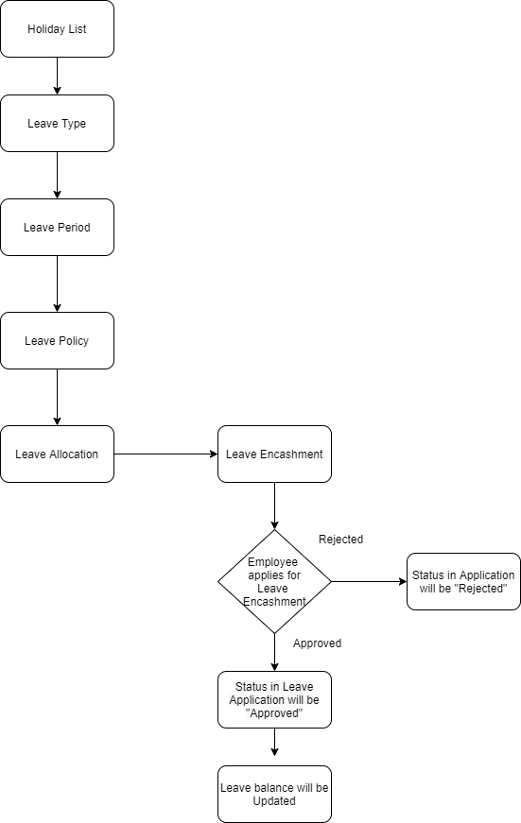

6.38.6 Use case
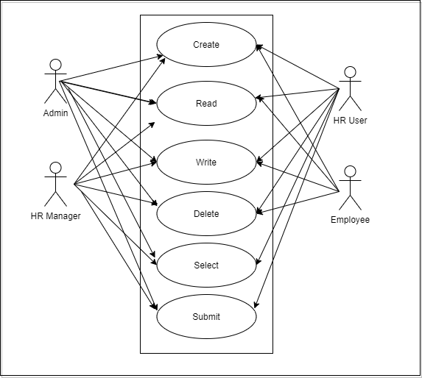

6.38.7 Form Elaboration
SL No. | Label | Type | Mandatory | Options
1 | Leave Period | Link | 1 | Leave Period
2 | Employee | Link | 1 | Employee
3 | Employee Name | Data | 0
4 | Department | Link | 0 | Department
5 | Company | Link | 1 | Company
6 |  | Column Break | 0
7 | Leave Type | Link | 1 | Leave Type
8 | Leave Allocation | Link | 0 | Leave Allocation
9 | Leave Balance | Float | 0
10 | Encashable days | Float | 0
11 | Amended From | Link | 0 | Leave Encashment
12 | Payroll | Section Break | 0
13 | Encashment Date | Date | 0
14 | Additional Salary | Link | 0 | Additional Salary
15 |  | Column Break | 0
16 | Currency | Link | 1 | Currency
17 | Encashment Amount | Currency | 0 | currency

6.38.8 Screen Authorization
Sl No. | Role | Level | Select | Read | Write | Create | Delete | Submit
1 | Admin | 0 | 1 | 1 | 1 | 1 | 1 | 1
2 | HR Manager | 0 | 1 | 1 | 1 | 1 | 1 | 1
3 | HR User | 0 | 1 | 1 | 1 | 1 | 1 | 1
4 | Employee | 0 | 1 | 1 | 1 | 1 | 1 | 0

6.38.9 Component And Module
Module Related:- HR,Finance,Payroll

6.38.10 Business Logic

1) Go to Leave Encashment list,click on New.

2) Select the Leave Period.

3) Select the Employee.Once the Employee is selected, the Employee's Department is automatically fetched.

4) Select Leave Type for which the Leave is Encashed. Make sure the Leave Type is encashable (the 'Allow Encashment' checkbox in the Leave Type is checked).

5) Select Encashment Date. Based on the date selected, the amount will be Encashed in that particular Payroll Entry.

6 Save and Submit.

6.38.11 Path of the screen
Home > Human Resources > Leaves > Leave Encashment

6.39 Shift Assignment

6.39.1 Overview
A Shift Assignment is created to assign a particular shift type to an employee for a specific period.

6.39.2 Description of Problem
Create a form to assign different shifts to different employees.It will collect information like Employee id(employee details will be automatically fetched),shift type,start date,end date and so on.

6.39.3 Dependency
Before creating a Shift Assignment, it is advisable you create the following documents:
1)Employee
2)Shift Type

6.39.4 A Table of Contents
1) Main Table:- TabShift Assignment

6.39.5 Flow Chart

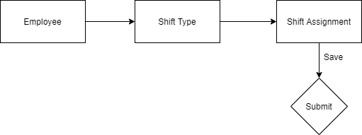

6.39.6 Use case
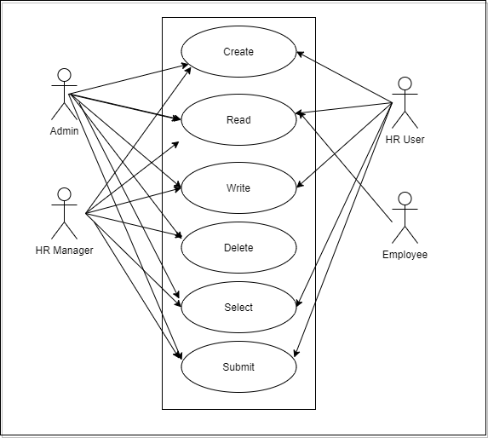

6.39.7 Form Elaboration
SL No. | Label | Type | Mandatory | Options
1 | Employee | Link | 1 | Employee
2 | Employee Name | Data | 0
3 | Shift Type | Link | 1 | Shift Type
4 | Status | Select | 0 | Active  Inactive
5 |  | Column Break | 0
6 | Company | Link | 1 | Company
7 | Start Date | Date | 1
8 | End Date | Date | 0
9 | Shift Request | Link | 0 | Shift Request
10 | Department | Link | 0 | Department
11 | Amended From | Link | 0 | Shift Assignment

6.39.8 Screen Authorization
Sl No. | Role | Level | Select | Read | Write | Create | Delete | Submit
1 | Admin | 0 | 1 | 1 | 1 | 1 | 1 | 1
2 | HR Manager | 0 | 1 | 1 | 1 | 1 | 1 | 1
3 | HR User | 0 | 1 | 1 | 1 | 1 | 0 | 1
4 | Employee | 0 | 0 | 1 | 0 | 0 | 0 | 0

6.39.9 Component And Module
Module Related:- HR,Finance,Payroll

6.39.10 Business Logic

1) Go to Shift Assignment list,click on New.

2) Select the Employee.

3) Select the Shift Type.

4) Set the Start Date and End Date.

5) Save and Submit.

Note:1The Assignment for active shift-type will be for a fixed period if there is an End Date otherwise, it will be treated as an ongoing shift with no End Date. Users can update the End Date and status even after submitting the document.

6.39.11 Path of the screen
Home > Human Resources > Shift Management > Shift Assignment

6.40 Shift Request

6.40.1 Overview
Shift Request is used by an employee to request for a particular Shift Type.

6.40.2 Description of Problem
Create a form to collect the list of shift request raised by employees.It will consist of information like shift type,Employee ID(employee details will be auto fetched),Approver will also be auto fetched from employee id,from date and to date.

6.40.3 Dependency
Before creating a Shift Request, it is advisable you create the following documents:
1)Employee
2)Shift Type

6.40.4 A Table of Contents
1) Main Table:- TabShift Request

6.40.5 Flow Chart

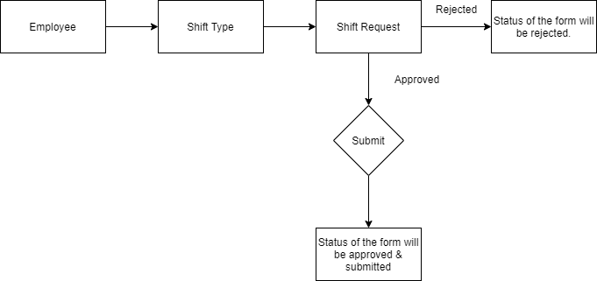

6.40.6 Use case
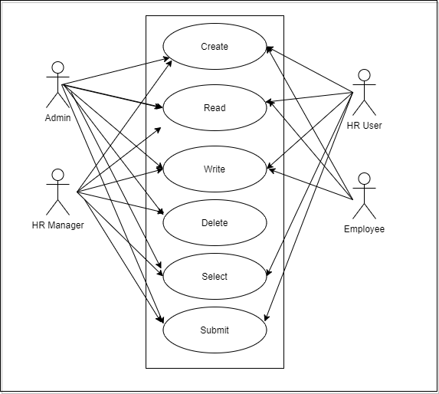

6.40.7 Form Elaboration
SL No. | Label | Type | Mandatory |  | Options
1 | Shift Type | Link | 1 | Shift Type
2 | Employee | Link | 1 | Employee
3 | Employee Name | Data | 0
4 | Department | Link | 0 | Department
5 | Status | Select | 1 | Draft  Approved  Rejected
6 |  | Column Break | 0
7 | Company | Link | 1 | Company
8 | Approver | Link | 1 | User
9 | From Date | Date | 1
10 | To Date | Date | 0
11 | Amended From | Link | 0 | Shift Request

6.40.8 Screen Authorization
Sl No. | Role | Level | Select | Read | Write | Create | Delete | Submit
1 | Admin | 0 | 1 | 1 | 1 | 1 | 1 | 1
2 | HR Manager | 0 | 1 | 1 | 1 | 1 | 1 | 1
3 | HR User | 0 | 1 | 1 | 1 | 1 | 0 | 1
4 | Employee | 0 | 0 | 1 | 1 | 1 | 0 | 0

6.40.9 Component And Module
Module Related:- HR,Finance,Payroll

6.40.10 Business Logic

1) Go to Shift Request List,click on New.

2) Select the Employee and Shift Type.

3) Set the Start Date and End Date.

5) Select the Approver. If the selected approver does not have access to the Shift Request document, it is shared with the approver with "submit" permission.

6)Save

7)Once the Shift Request is Approved and submitted, it creates a Shift Assignment.

6.40.11 Path of the screen
Home > Human Resources > Shift Management > Shift Request

6.41 Attendance

6.41.1 Overview

Attendance is a record stating whether an Employee has been present on a particular day or not.

6.41.2 Description of Problem
Create a form to mark and record the attendance of an Employee on a daily basis.It will consist of information like Employee id(employee details like employee name,department and so on will be auto fetched),status(Present/absent/WFH),shift details,check boxes like late entry,early entry.

6.41.3 Dependency
Before creating a Attendance, it is advisable you create the following documents:
1)Employee
2)Shift Type

6.41.4 A Table of Contents
1) Main Table:- TabAttendance

6.41.5 Flow Chart

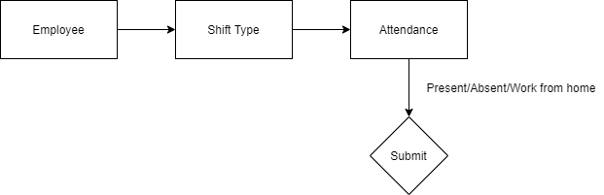

6.41.6 Use case

6.41.7 Form Elaboration
SL No. | Label | Type | Mandatory | Options
1 |  | Section Break | 0 | Simple
2 | Series | Select | 1 | HR-ATT-.YYYY.-
3 | Employee | Link | 1 | Employee
4 | Employee Name | Data | 0
5 | Working Hours | Float | 0
6 | Status | Select | 1 | Present  Absent  On Leave  Half Day  Work From Home
7 | Leave Type | Link | 0 | Leave Type
8 | Leave Application | Link | 0 | Leave Application
9 |  | Column Break | 0
10 | Attendance Date | Date | 1
11 | Company | Link | 1 | Company
12 | Department | Link | 0 | Department
13 | Attendance Request | Link | 0 | Attendance Request
14 | Details | Section Break | 0
15 | Shift | Link | 0 | Shift Type
16 | In Time | Datetime | 0
17 | Out Time | Datetime | 0
18 |  | Column Break | 0
19 | Late Entry | Check | 0
20 | Early Exit | Check | 0
21 | Amended From | Link | 0 | Attendance

6.41.8 Screen Authorization
Sl No. | Role | Level | Select | Read | Write | Create | Delete | Submit
1 | Admin | 0 | 1 | 1 | 1 | 1 | 1 | 1
2 | HR Manager | 0 | 1 | 1 | 1 | 1 | 1 | 1
3 | HR User | 0 | 1 | 1 | 1 | 1 | 0 | 1
4 | Employee | 0 | 0 | 1 | 0 | 0 | 0 | 0

6.41.9 Component And Module
Module Related:- HR,Finance,Payroll

6.41.10 Business Logic

1) Go to Attendance list,click on New.

2) Select the Employee.

3) Select the Attendance Date and Shift type.

5) Select the Status(Present,Absent,On LEave,Half Day,Work From Home).

6)Save and Submit.

Note:1 Attendance cannot be marked for future dates.

Marking Unmarked Attendance:

In case the attendance for some employees is not marked, you can mark them as present, absent, or half-day.

Go to the Attendance list.
- Click on the Mark Attendance button.
- A dialog will appear.
- Select the Employee and Month.
- Select the Status whether Present, Absent, or Half Day.
- If you want to exclude holidays while doing so, check Exclude Holidays.
- Select the dates on which you want to mark attendance for a selected Employee.
- Click on the Mark Attendance button and click on Yes.

6.41.11 Path of the screen
Home > Human Resources > Attendance

6.42 Employee Attendance Tool

6.42.1 Overview
Employee Attendance Tool allows you to mark attendance of multiple employees for a particular date.

6.42.2 Description of Problem
Create a form or tool which will allow to add attendance records for multiple employees based on their Department and Branch for a given day.

6.42.3 Dependency
Before creating an Employee Attendance, it is advisable you create the following documents:
1)Employee
2)Department
3)Branch

6.42.4 A Table of Contents
No records.

6.42.5 Flow Chart

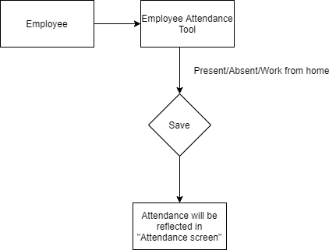

6.42.6 Use case
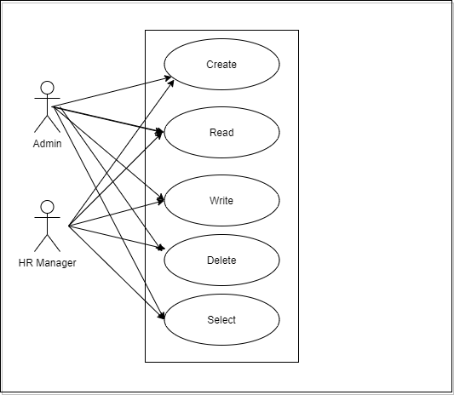

6.42.7 Form Elaboration
SL No. | Label | Type | Mandatory | Options
1 | Date | Date | 0
2 | Department | Link | 0 | Department
3 |  | Column Break | 0
4 | Branch | Link | 0 | Branch
5 | Company | Link | 0 | Company
6 | Unmarked Attendance | Section Break | 0
7 | Employees HTML | HTML | 0
8 | Marked Attendance | Section Break | 0
9 | Marked Attendance HTML | HTML | 0

6.42.8 Screen Authorization
Sl No. | Role | Level | Select | Read | Write | Create | Delete | Submit
1 | Admin | 0 | 1 | 1 | 1 | 1 | 1 | 1
2 | HR Manager | 0 | 1 | 1 | 1 | 1 | 1 | 1

6.42.9 Component And Module
Module Related:- HR,Finance,Payroll

6.42.10 Business Logic

1) Enter the Date.

2) Select the Department and Branch.

3) Select the Employees.

5) Mark the Attendance

Note:1 Attendance cannot be marked for future dates.Once the attendance is marked using the Employee Attendance Tool, the employee attendance is saved in the

6.42.11 Path of the screen
Home > Human Resources > Attendance >Employee Attendance Tool

6.43 Attendance Request

6.43.1 Overview
Using the Attendance Request, employees can submit their attendance request for the days when their attendance wasn't marked due to various reasons such as on-site duty or work from home.

6.43.2 Description of Problem
Create a form to collect list of attendance requests raised by employees.It will consist of information like Employee id(employee details like employee name,department will be auto fetched),from date,to date,reason and explanation.

6.43.3 Dependency
Before creating an Attendance Request, it is advisable you create the following documents:
1)Employee

6.43.4 A Table of Contents
1) Main Table:- TabAttendance Request

6.43.5 Flow Chart
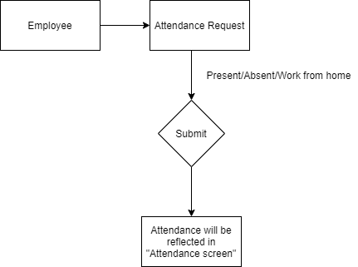

6.43.6 Use case
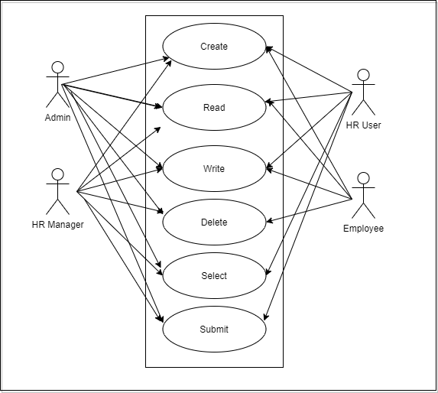

6.43.7 Form Elaboration
SL No. | Label | Type | Mandatory |  | Options
1 | Employee | Link | 1 | Employee
2 | Employee Name | Data | 0
3 | Department | Link | 0 | Department
4 |  | Column Break | 0
5 | Company | Link | 1 | Company
6 | From Date | Date | 1
7 | To Date | Date | 1
8 | Half Day | Check | 0
9 | Half Day Date | Date | 0
10 | Reason | Section Break | 0
11 | Reason | Select | 1 | Work From Home  On Duty
12 |  | Column Break | 0
13 | Explanation | Small Text | 0
14 | Amended From | Link | 0 | Attendance Request

6.43.8 Screen Authorization
Sl No. | Role | Level | Select | Read | Write | Create | Delete | Submit
1 | Admin | 0 | 1 | 1 | 1 | 1 | 1 | 1
2 | HR Manager | 0 | 1 | 1 | 1 | 1 | 1 | 1
3 | HR User | 0 | 1 | 1 | 1 | 1 | 1 | 1
4 | Employee | 0 | 0 | 1 | 1 | 1 | 1 | 0

6.43.9 Component And Module
Module Related:- HR,Finance,Payroll

6.43.10 Business Logic

1) Go to Attendance Request list, click on New.

2) Select Employee who wants to submit the Attendance Request.

3) Select the From Date and To Date of Attendance Request. .

5) Select Reason and enter Explanation (optional).

6) Save and Submit.

Note:1 On submission of the same, Attendance documents will be created for the days you mentioned as shown.

6.43.11 Path of the screen
Home > Human Resources > Attendance > Attendance Request

6.44 Employee Checkin

6.44.1 Overview
Employee Checkin is used to keep a log of all the check-ins and check-outs of an employee in the organization. Most organizations use this for attendance, shift management, and working hours calculations.

6.44.2 Description of Problem
Create a form to collect list of employee checkin.It will consist of information like Employee Id(employee details will be fetched),Log type,time and so on.

6.44.3 Dependency
Before creating an Employee Checkin, it is advisable you create the following documents:
1)Employee
If you want shifts to be determined in employee checkins and want to process auto-attendance, then you need to create the following documents too:
- Shift Type
- Shift Assignment or set a default shift in Employee master

6.44.4 A Table of Contents
1) Main Table:- TabEmployee Checkin

6.44.5 Flow Chart
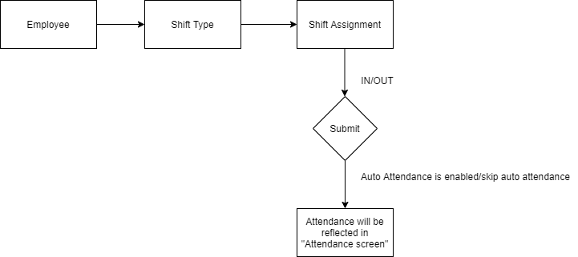

6.44.6 Use case
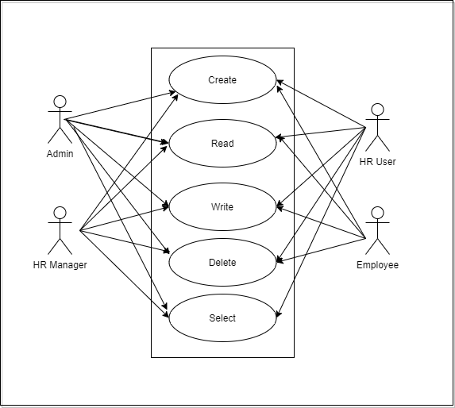

6.44.7 Form Elaboration
Sl No. | Label | Type | Mandatory | Options
1 | Employee | Link | 1 | Employee
2 | Employee Name | Data | 0
3 | Log Type | Select | 0 | IN  OUT
4 | Shift | Link | 0 | Shift Type
5 |  | Column Break | 0
6 | Time | Datetime | 1
7 | Location / Device ID | Data | 0
8 | Skip Auto Attendance | Check | 0
9 | Attendance Marked | Link | 0 | Attendance
10 | Shift Start | Datetime | 0
11 | Shift End | Datetime | 0
12 | Shift Actual Start | Datetime | 0
13 | Shift Actual End | Datetime | 0

6.44.8 Screen Authorization
Sl No. | Role | Level | Select | Read | Write | Create | Delete | Submit
1 | Admin | 0 | 1 | 1 | 1 | 1 | 1 | 0
2 | HR Manager | 0 | 1 | 1 | 1 | 1 | 1 | 0
3 | HR User | 0 | 1 | 1 | 1 | 1 | 1 | 0
4 | Employee | 0 | 0 | 1 | 1 | 1 | 1 | 0
5 | Employee | 1 | 0 | 1 | 0 | 0 | 0 | 0
6 | HR User | 0 | 0 | 1 | 1 | 0 | 0 | 0
7 | HR Manager | 0 | 0 | 1 | 1 | 0 | 0 | 0

6.44.9 Component And Module
Module Related:- HR,Finance,Payroll

6.44.10 Business Logic

1) Go to Employee Checkin list, click on New.

2) Select Employee ..

3) Select the date and time for the log..

5) Set Log Type as IN/OUT.

6) Save

Note:1 If you have set up shifts and shift assignments, the Employee Checkin will set the appropriate shift in which the timestamp falls after saving.

6.44.11 Path of the screen
Home > Human Resources > Attendance > Employee Checkin

6.45 Appraisal Template

6.45.1 Overview
The Appraisal Template is a blueprint which contains a predefined list of Activities and Key Result Areas(KRAs) along with the weightage of the same.

6.45.2 Description of Problem
Create a form to collect list of different templates for Appraisal based on department and designation.It will consist of information like Appraisal Template Title,description, Goals with KRA(Key Result Area) and Weightage for each KRA.

6.45.3 Dependency
Before creating an Appraisal Template, it is advisable you create the following documents:
- Department
- Designation

6.45.4 A Table of Contents
1) Main Table:- TabAppraisal Template
2) Child Table:- TabAppraisal Template Goal

6.45.5 Flow Chart

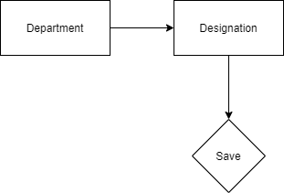

6.45.6 Use case
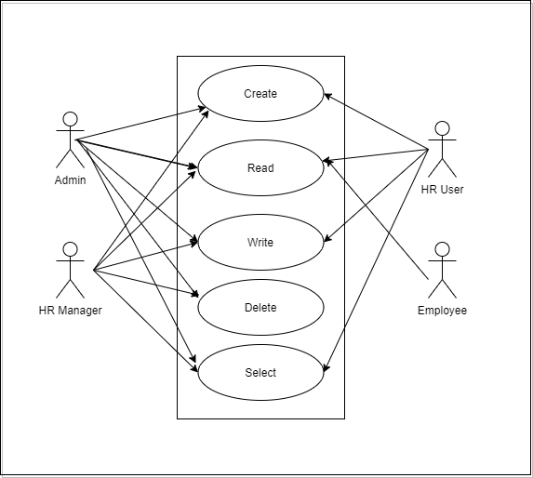

6.45.7 Form Elaboration
SL No. | Label | Type | Mandatory | Options
1 | Appraisal Template Title | Data | 1
2 | Description | Small Text | 0
3 | Goals | Table | 1 | Appraisal Template Goal

6.45.8 Screen Authorization
Sl No. | Role | Level | Select | Read | Write | Create | Delete | Submit
1 | Admin | 0 | 1 | 1 | 1 | 1 | 1 | 0
2 | HR Manager | 0 | 1 | 1 | 1 | 1 | 1 | 0
3 | HR User | 0 | 1 | 1 | 1 | 1 | 0 | 0
4 | Employee | 0 | 0 | 1 | 0 | 0 | 0 | 0

6.45.9 Component And Module
Module Related:- HR,Finance,Payroll

6.45.10 Business Logic

1) Go to Appraisal Template list, click on New.

2) Enter the Appraisal Template Title.

3) Give the description.

5) Enter the KRA and weightage in “Goals”table.

6) Save

6.45.11 Path of the screen
Home > Human Resources > Appraisal > Appraisal Template

6.46 Appraisal

6.46.1 Overview
A performance appraisal is a method by which the job performance of an employee is documented and evaluated.

6.45.2 Description of Problem
Create a form to manage Employee Appraisals by creating template for each role with the parameters that define the performance by giving appropriate weightage to each parameter.

6.45.3 Dependency
Before creating an Appraisal , it is advisable you create the following documents:
1)Employee

6.45.4 A Table of Contents
1) Main Table:- TabAppraisal
2) Child Table:- TabAppraisal Goal

6.45.5 Flow Chart

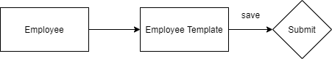

6.45.6 Use case
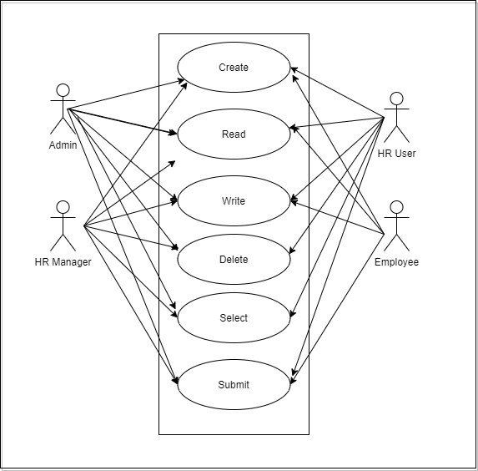

6.45.7 Form Elaboration
SL No. | Label | Type | Mandatory | Options
1 |  | Section Break | 0
2 | Series | Select | 1 | HR-APR-.YY.-.MM.
3 | Appraisal Template | Link | 1 | Appraisal Template
4 | For Employee | Link | 1 | Employee
5 | For Employee Name | Data | 0
6 |  | Column Break | 0
7 | Status | Select | 1 | Draft  Submitted  Completed  Cancelled
8 | Start Date | Date | 1
9 | End Date | Date | 1
10 | Department | Link | 0 | Department
11 | Goals | Section Break | 0 | Simple
12 | Goals | Table | 0 | Appraisal Goal
13 | Total Score (Out of 5) | Float | 0
14 |  | Section Break | 0
15 | Remarks | Text | 0
16 |  | Section Break | 0
17 | Company | Link | 1 | Company
18 |  | Column Break | 0
19 | Amended From | Link | 0 | Appraisal

6.45.8 Screen Authorization
Sl No. | Role | Level | Select | Read | Write | Create | Delete | Submit
1 | Admin | 0 | 1 | 1 | 1 | 1 | 1 | 1
2 | HR Manager | 0 | 1 | 1 | 1 | 1 | 1 | 1
3 | HR User | 0 | 1 | 1 | 1 | 1 | 0 | 1
4 | Employee | 0 | 0 | 1 | 1 | 1 | 0 | 1

6.45.9 Component And Module
Module Related:- HR,Finance,Payroll

6.45.10 Business Logic

1) Go to Appraisal, click on New.

2) Select the Appraisal Template. If not created, create an Appraisal Template. Enter the Appraisal Template Name and the Key Result Areas (KRAs) along with the weightage of the same.

3) After selecting the Appraisal Template, select the Employee, Start Date and End Date.

5) Based on the template selected, the KRAs will be fetched in the Goals section. Enter the score (0-5)for each KRA. Based on the weightage mentioned, the Score Earned will be calculated for each KRA.

6) Save and Submit.

6.45.11 Path of the screen
Home > Human Resources > Appraisal

